**NIFTY PREDICTION FOR 17/11/2017:**

**NIFTY REVERSE AFTER MAKING 50% RETRACEMENT AND NOW READY TO FLY TOWARDS 10800 PLUS.**

**SAR: 10275NS.**

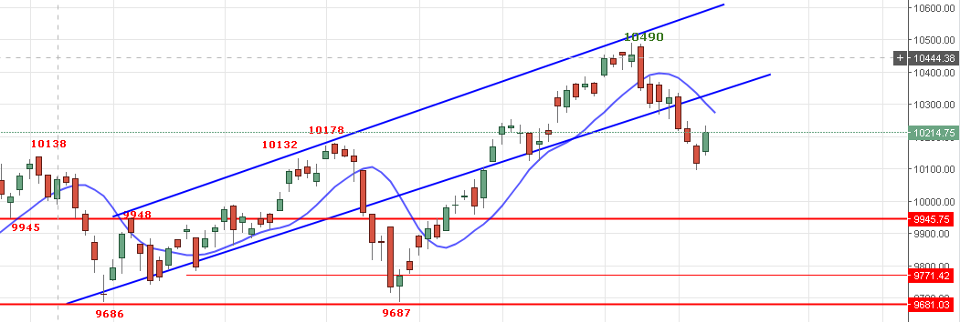

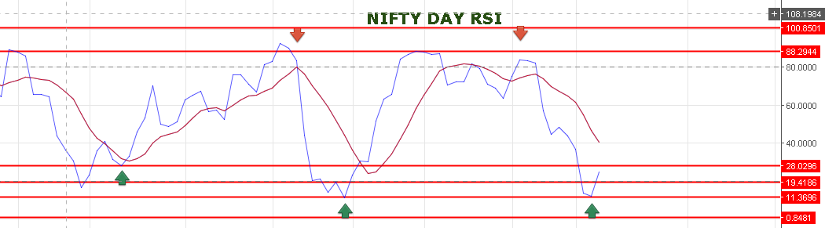

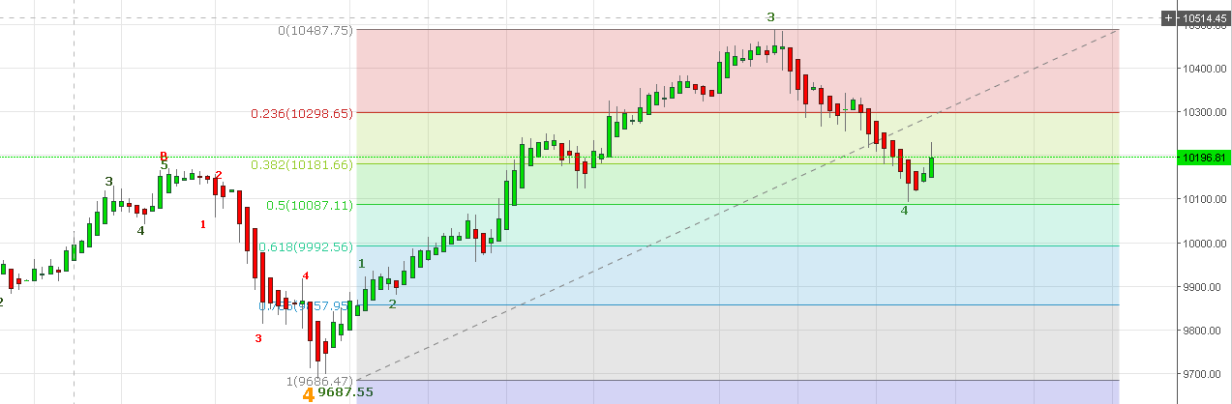

**GAP UP OPENING EXPECTED TOMORROW NEAR 10244-10258 LEVELS. 10275 WILL ACT AS RESISTANCE NEXT IS 10298 BEING SUPPORT NOW 10200-10180NS.PRICE NEED TO GIVE WEEKLY CLOSE ABOVE 10253 TO CONTINUE TREND.**

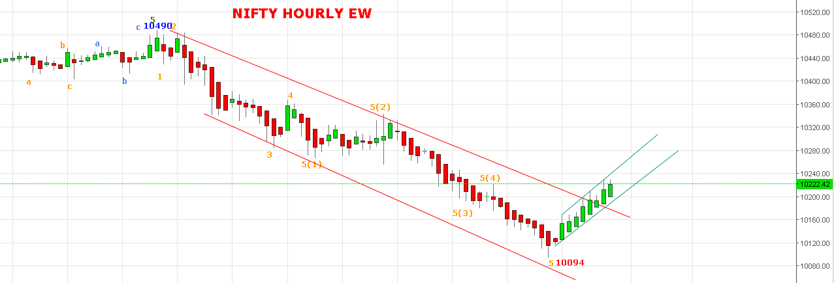

**WAVE 5TH ASSUME TO BE DONE IF PRICE DO NOT FALL BELOW 10170NS AND PRICE MUST TRADE ABOVE 10244NS TO VALIDATE THE ABOVE WAVE COUNT. IF PRICE GOES BELOW 10170NS AND REMAIN BELOW IT MORE THAN TWO HOURLY CLOSING THEN PRICE WILL BREAK 10094NS AND WILL MAKE NEW LOW. BELOW 10094 NS TARGETS 10010-9980-9830NS.**

**CURRENTLY ASSUME WAVE 5(5)(1)(i) IN PROGRESS.**

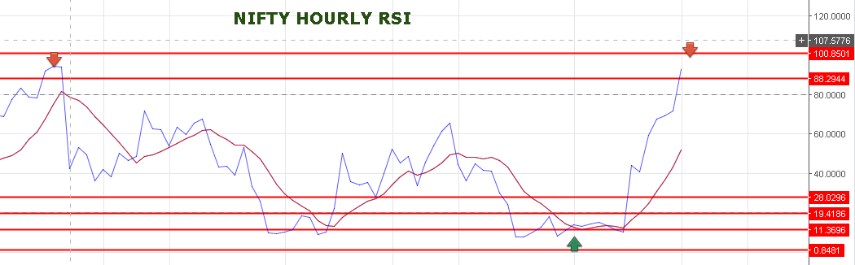

**HOURLY RSI NOW ENTERED AT OB ZONE.**

**WEAKNESS BELOW 10193NS.**

**RESISTANCE: 10251-10265-10288-10308.**

**HOLDING LONG IN NF STOP NOW 10215NF.**

**BOOK NF @10299-10312-10340-103560.**

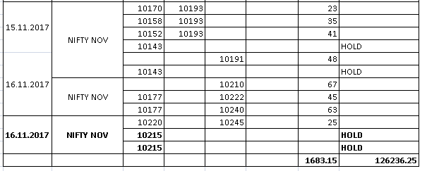

**OPTIONS:**

**10300CE STOP NOW 53. 10500CE STOP NOW 12. BUY 10300PE @119 STOP 109 TARGETS 135.**

