NIFTY PREDICTION FOR 25/10/2017:
NIFTY IS READY TO MAKE NEW LIFE HIGH IF 10180NS HOLD.
SAR: 10168NS.
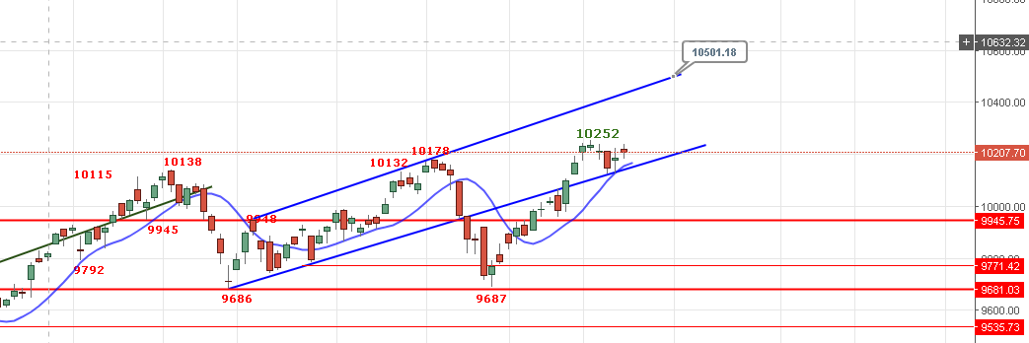
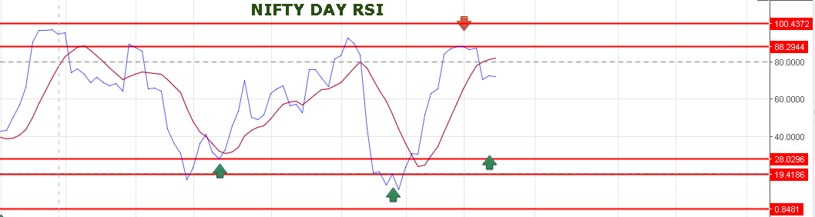
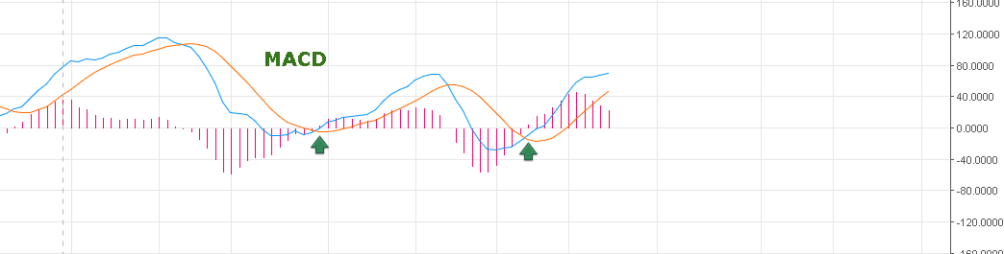
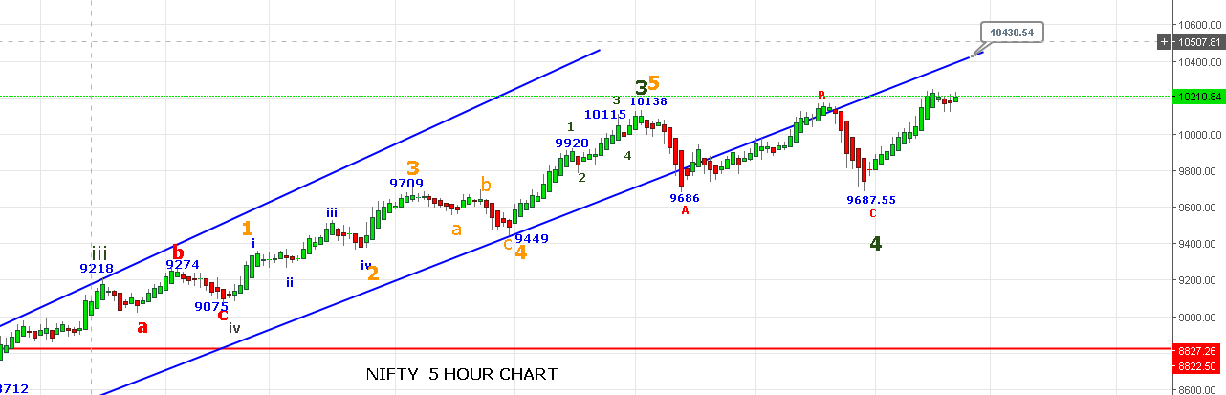
REVERSAL POINT 10172NS.
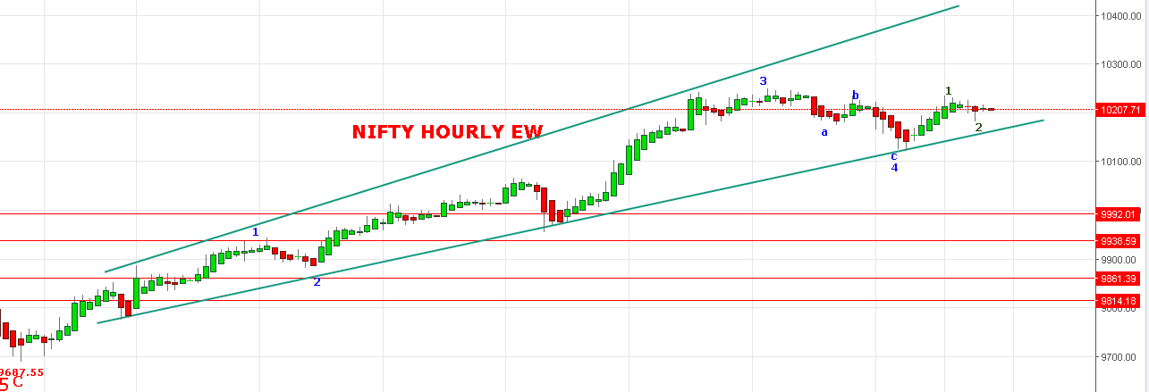
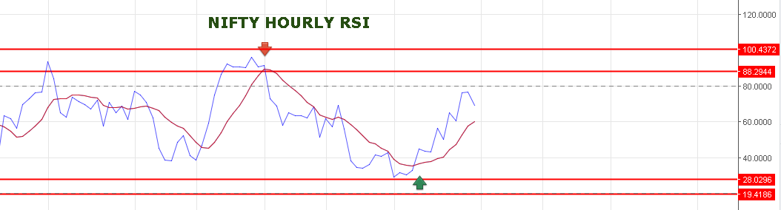
RESISTANCE NOW 10237-10271-10291-10305-10330-10375.
SUPPORT NOW 10180-10155NS.
BEARISH IF CLOSED BELOW 10172NS.
HOLDING LONG @10164 NOV NF STOP NOW 10207NF TARGETS 10295-10320-10352.
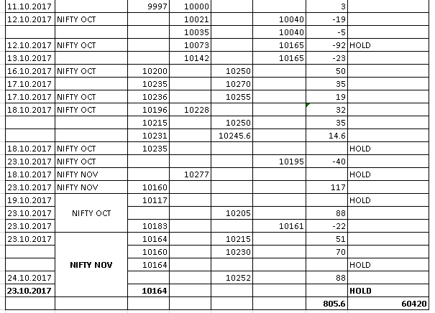

OPTIONS:
HOLDING LONG IN 10300NOV CE @77 AND 10200CE OCT @22. STOP NOW 96 & 35 FOR TARGETS:
10300CE NOV TARGETS 142>160>189>202>234.
10200CE OCT TARGETS 71-79>95-106>120-160.
BUY 10250PE OCT @ 67+ STOP 59 TARGETS 79-85-93-115.
BUY 9600PE/9800PE NOV NEAR 10305-10375NS.
