NIFTY PREDICTION FOR 01/11/2017:
NIFTY FORMS BULLISH ENGULFING CANDLE IN THE MONTH OF OCTOBER 2017.
MONTH SAR: 9582NS.
DAY SAR: 10277NS.
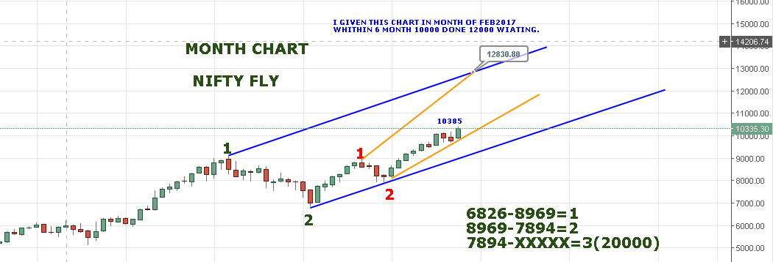
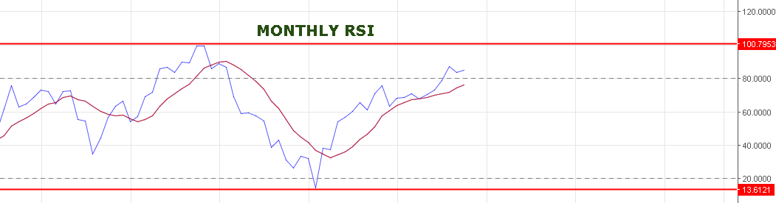
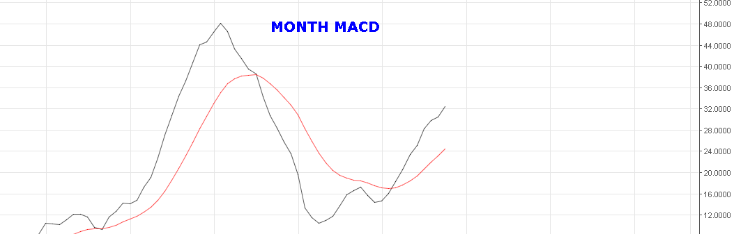
NOVEMBER MONTH RANGE: 9600-11140NS.
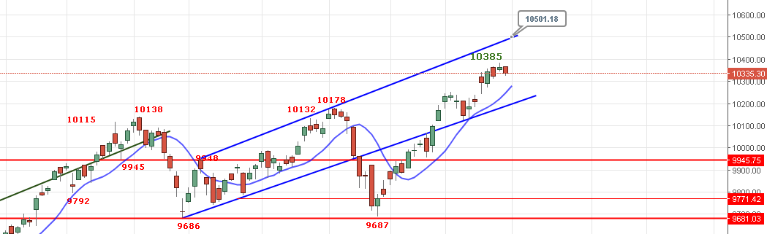
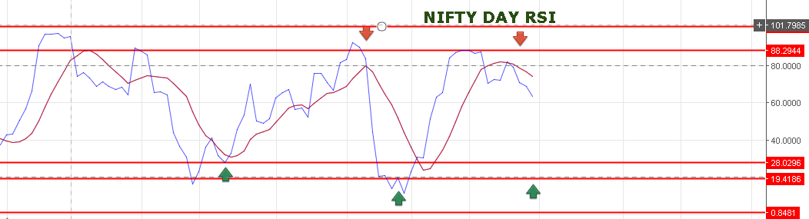

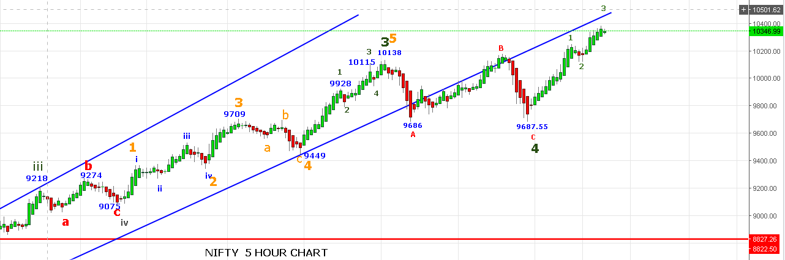
REVERSAL POINT 10316NS.
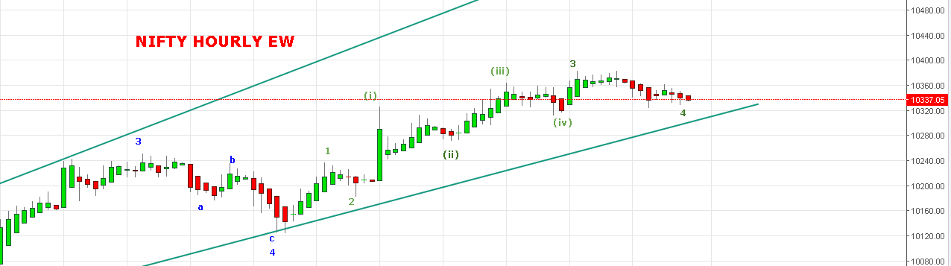
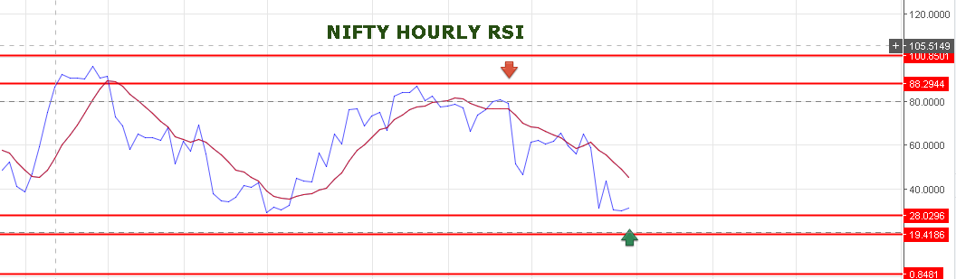
DAILY RSI NEAR TO OVERSOLD ZONE AND SHARP BOUNCE EXPECTED.
BREAKOUT ABOVE 10366 NS TARGETS 10404-10410>10432>10536NS.
BEARISH BELOW 10316NS FOR 10298-10282<10250-10235NS.
WE ARE HOLDING LONG IN NF STOP NOW 10350NF TARGETS 10406-10429-10451.
SHORT NF @10348-10345 STOP 10368 TARGETS 10321-10308<10295-10286<10278-10272.
OPTIONS:
HOLDING 10450CE STOP NOW 83 TARGETS 107-115>130-142.
BUY 10200PE @85-87 STOP 77 TARGETS 94-105-113-122.

