NIFTY PREDICTION FOR 22/09/2017:
NIFTY HOLDING BELOW 10101NS WILL MOVE TOWARDS 9980-9950 LEVELS.
SAR: 10101.
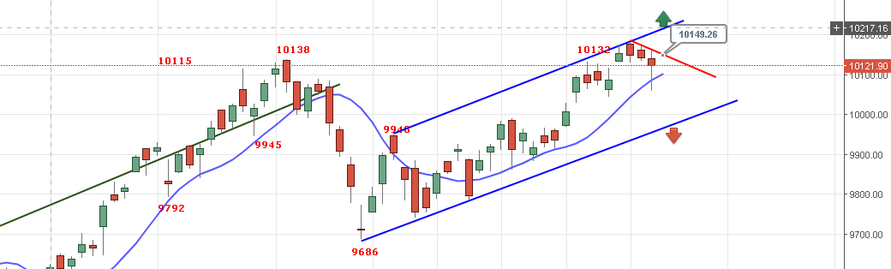

PRICE HOLDING BELOW 10149 WILL MOVE TOWARDS 10040-10020<9980-9950.
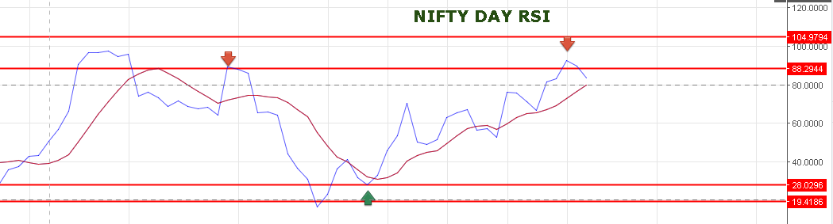
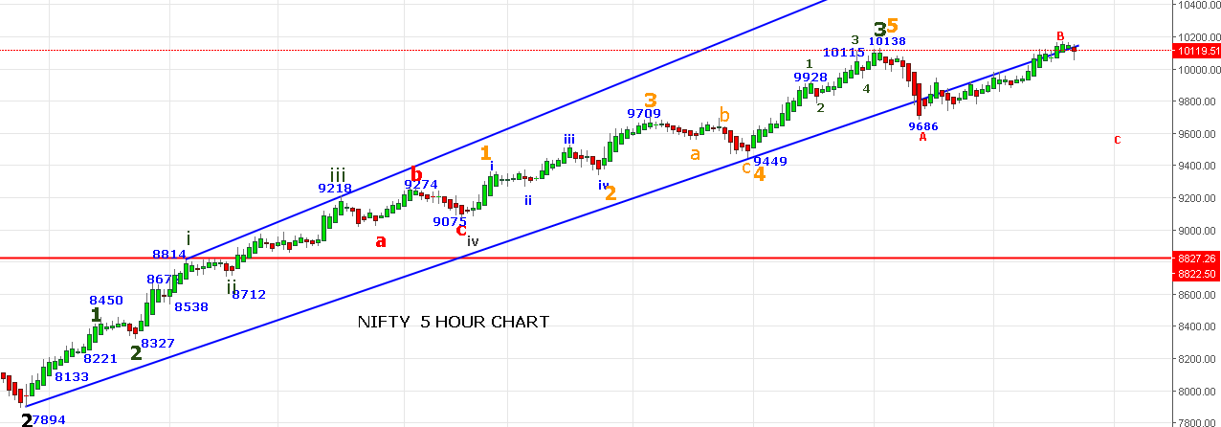
BULLISH ONLY ABOVE 10162NS.
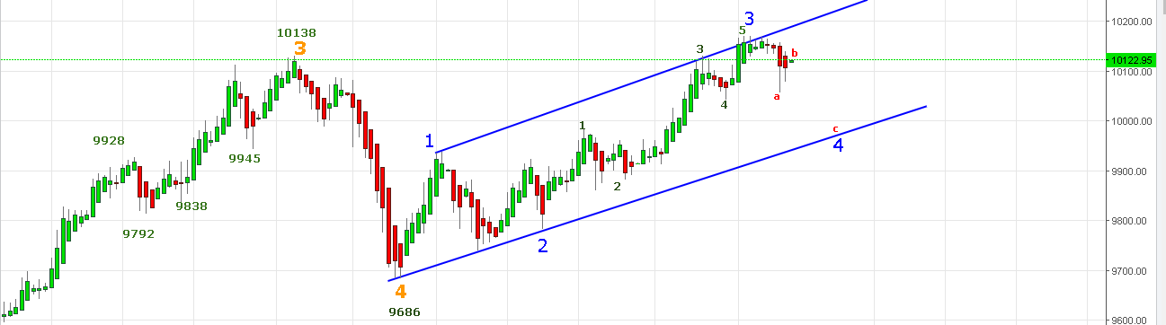

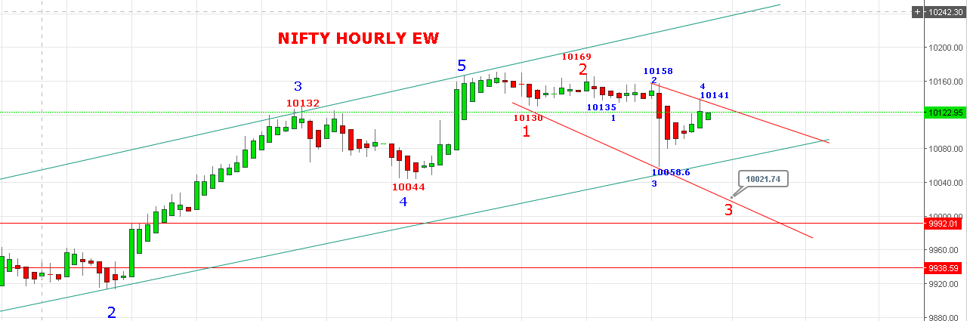
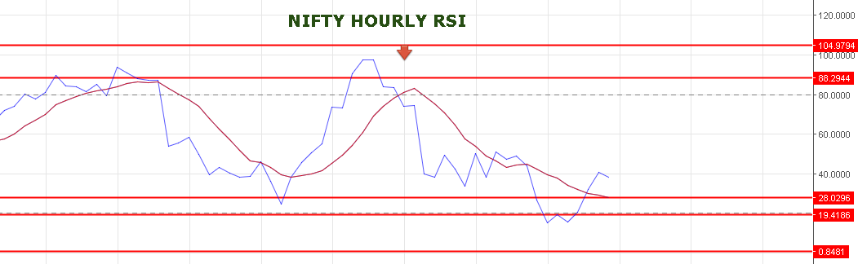
IF PRICE SUSTAIN ABOVE 10158 FOR 15 MINTS THEN ABOVE VIEW IN THE CHART NEGATED.
SHORT NS BELOW 10111NS FOR 10040-10020-9980-9960 LEVELS.
BUY NS ABOVE 10162 FOR 10190-10213-10230-10270.
WE DON’T HAVE ANY POSITION IN NF.
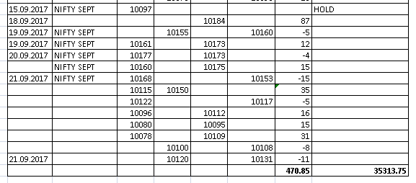
BUY NF @10160 STOP 10148 TARGETS 10182-10194.
SHORT NF @10122 STOP 10139 TARGETS 10105-10084<10020.
OPTIONS:
HOLDING 10100PE AND 10150CE. CE STOP 40. PE STOP 29.
