NIFTY PREDICTION FOR 18/09/2017:
NIFTY ABLE TO HOLD 10044 LEVELS NOW READY TO MAKE NEW LIFE HIGH.
SAR: 10015NS.
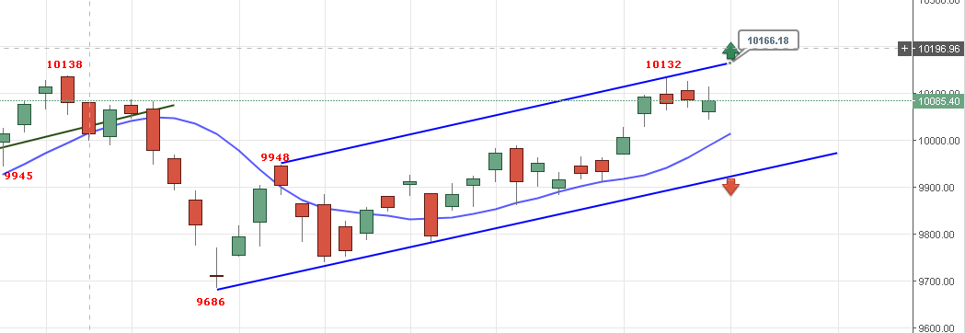
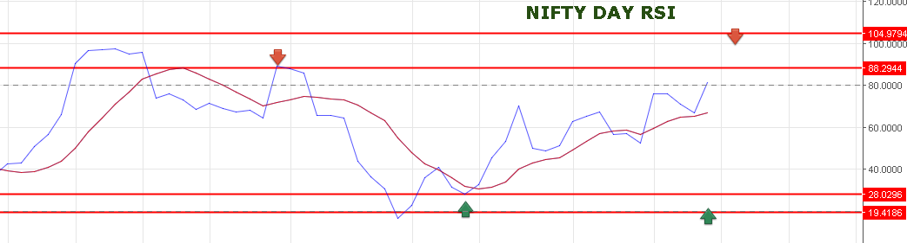
DAY RSI WILL BE OVERBOUGHT ZONE NEAR 10190-10223 LEVELS.
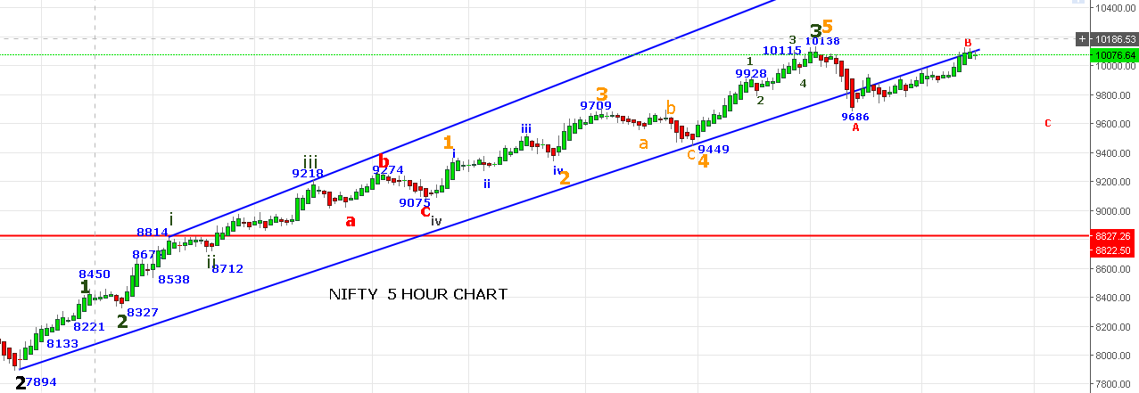
REVERSAL POINT NOW 10040NS. BEARISH BELOW 10040NS.
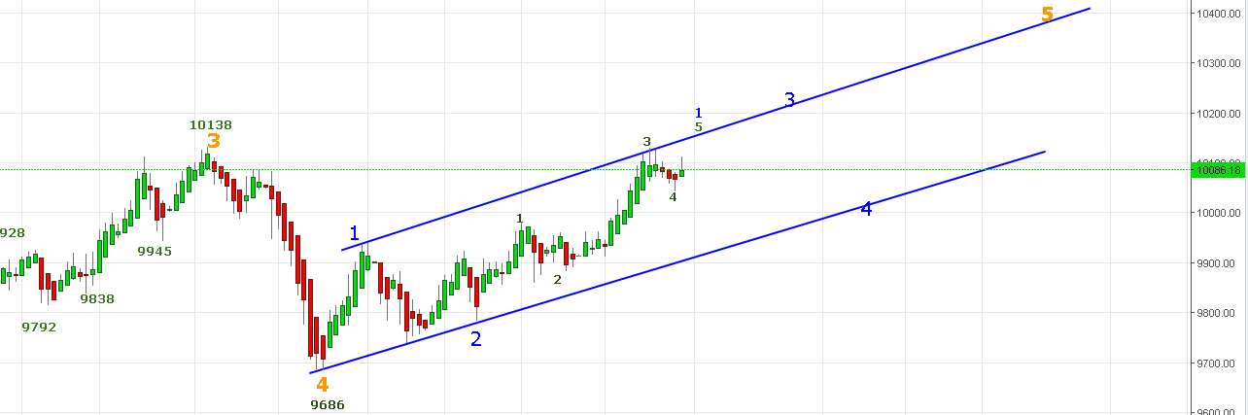
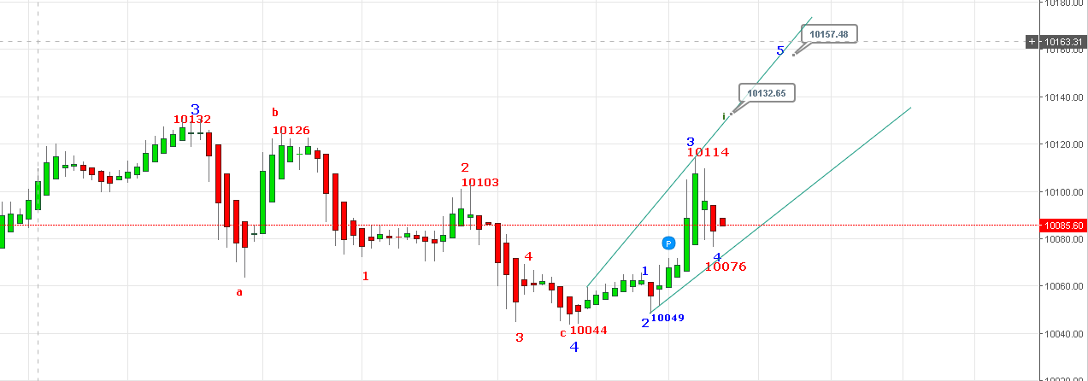
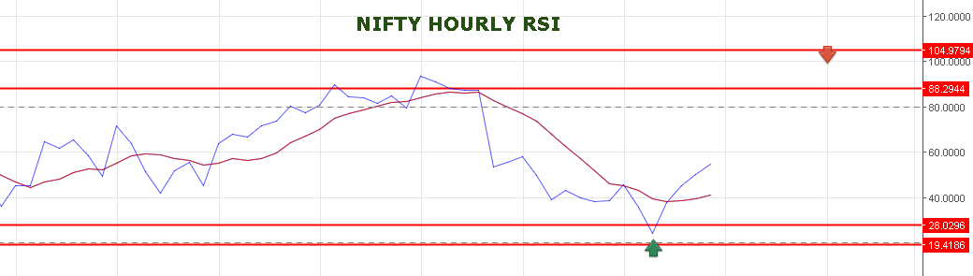
PRICE ABLE TO HOLD 10044 END OF INNER WAVE 4TH AND 5TH START FOR 10146-10157-10223 LEVELS.
A GAP UP OPENING EXPECTED ON MONDAY NEAR 10119-10132 LEVELS.
BREAKOUT ABOVE 10157 TARGETS 10090NS.
WEAKNESS BELOW 10070NS. BREAKDOWN BELOW 10040 TARGETS 10010-9977NS.
RESISTANCE LEVEL NOW 10136-10153-10190.
SUPPORT LEVEL NOW 10078-10072.

WE ARE HOLDING LONG NF @10097 STOPS NOW 10066NF.
ACTUALLY WE HOLD LONG ON FRIDAY @10070NF BUT LONDON BLAST CHANGED THE MIND AS PRICE FALL QUICKLY FROM 10083 NF TO 10069 NF WITHIN A MINT WE EXIT OUR LONG AND WENT SHORT EXPECTING WAVE 4 CAN FURTHER EXTEND BUT MARKET RECOVERED VERY QUICKLY IGNORING THE EVENT AS FAST RECOVERY AT GLOBAL MARKET. FINALLY ENTERED LONG WHEN NIFTY SPOT SURPASSED 10076 LEVELS. EW COUNTS CONFIRMED THAT 5TH WAVE STARTED.
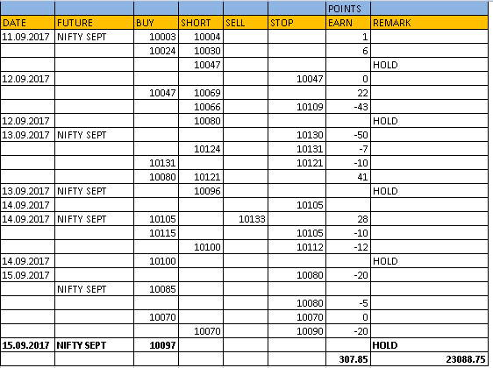

NF TARGETS 10138-10148-10161>10209. MUST BOOK PROFIT ONCE NEAR 10148-10161.
SHORT NF @10064 TARGETS 10043<10020-10005.STOP 10080NF.
OPTIONS:
HOLDING 10150CE STOP 40 TARGETS 66-74-90-101-115.
BUY 10100PE @82 STOP 70 TARGETS 86-96-103-112.
