NIFTY PREDICTION FOR 29/08/2017:
NIFTY FORMS DOJI AFTER MAKING HIGHER LOW ONCE AGAIN.
SAR: 9834NS.
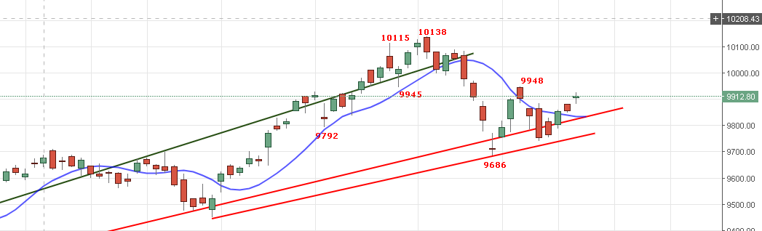
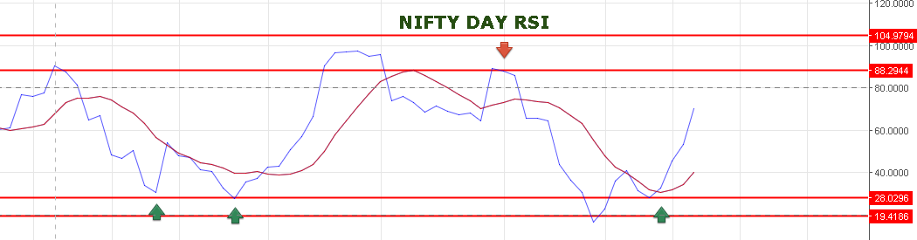
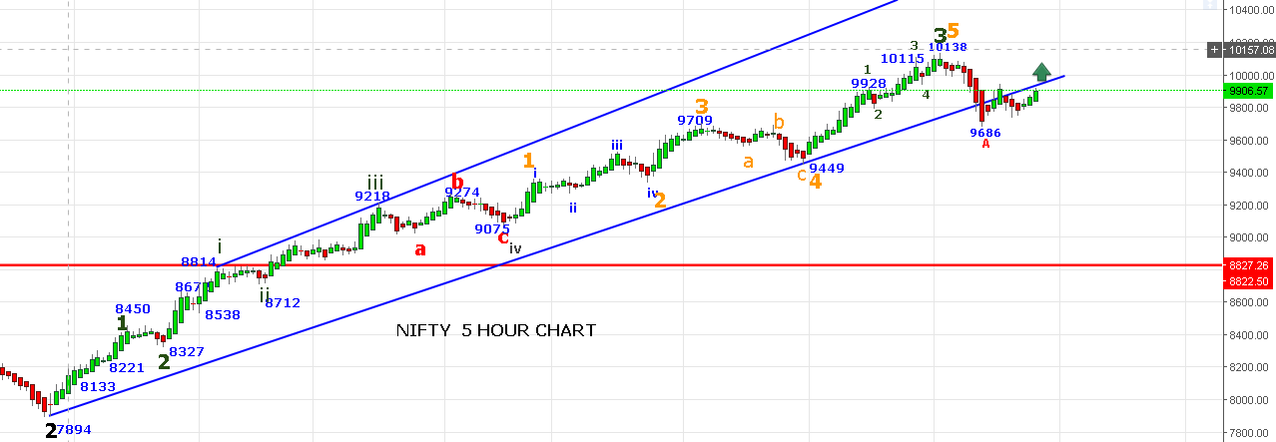
BULLISH ONLY ABOVE 9950NS NOW. BEARISH BELOW 9850NS.

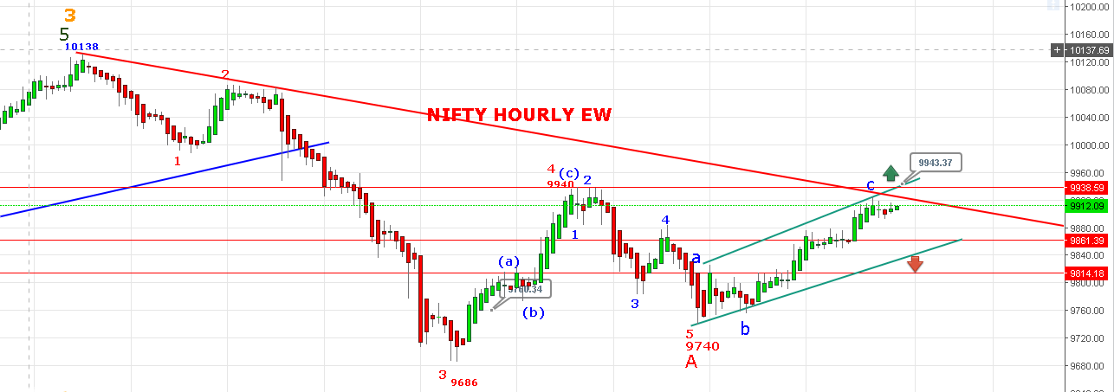

LOOKING TO THE CHART 9925-23 IS NOW THE HURDLE TO SURPASS. IF ABLE TO CROSSS THEN NEXT RESISTANCE @9943-9947.
POSITIONAL BUY NS ABOVE 9972 TARGETS 10020-10050NS.
POSITIONAL SHORT 9920-9950NS STOP 9965NS TARGETS 9685-9595 NS.
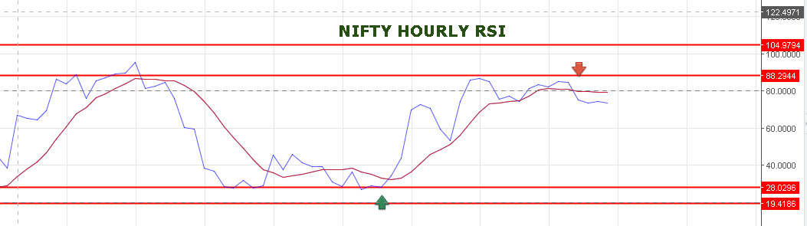
HOURLY RSI IS BREAKDOWN. BLUES LINE IS BELOW RED LINE.
WE ARE HOLDING SHORTS IN NF STOP 9965NS.
TODAY’S TRADE:
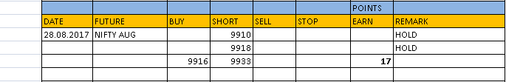
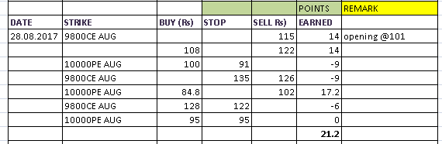

TOMORROW’S TRADE STRATEGY:
IF NF TRADE ABOVE 9940 THEN EXIT SHORT AND BUY @9945 STOP 9925NF TARGETS 9955-9965-9979.
OPTION:
BUY 9800CE @133 STOP 124 TARGETS 146-154-170. SHORT 9800CE @99 STOP 111 TARGETS 88-77-63.
BUY 10000PE @108+ STOP 95 TAREGTS 114-128-138-150.

