NIFTY PREDICTION FOR 23/08/2017:
NIFTY BOUNCE BUT FAILED TO CROSS ABOVE 9830 AND CLOSED BELOW 9800 .
SAR: 9845NS.
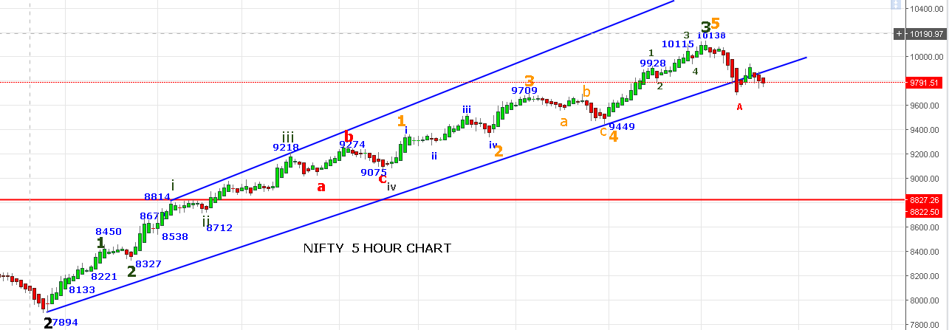

NIFTY HOLDING 9760NS WILL TRY TO CROSS 9833 LEVEL AND TO TEST 9875-9890 LEVELS TOMORROW.
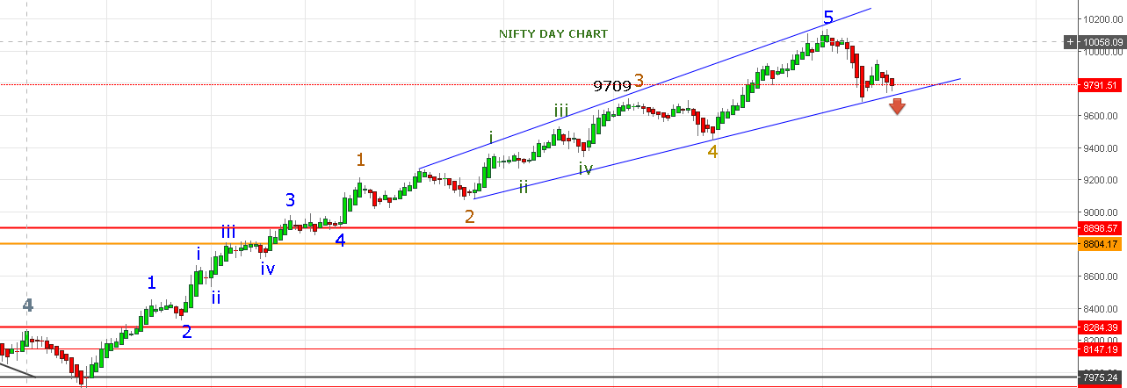
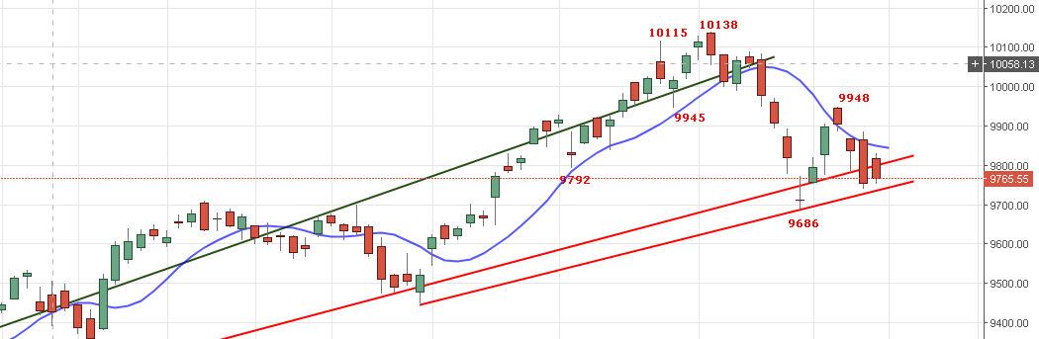
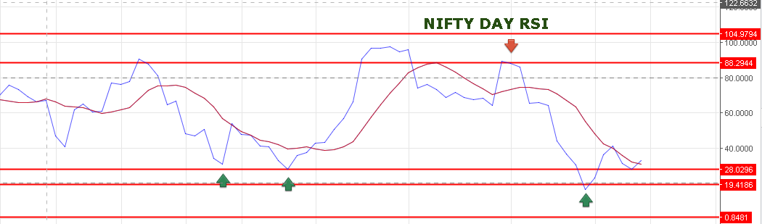
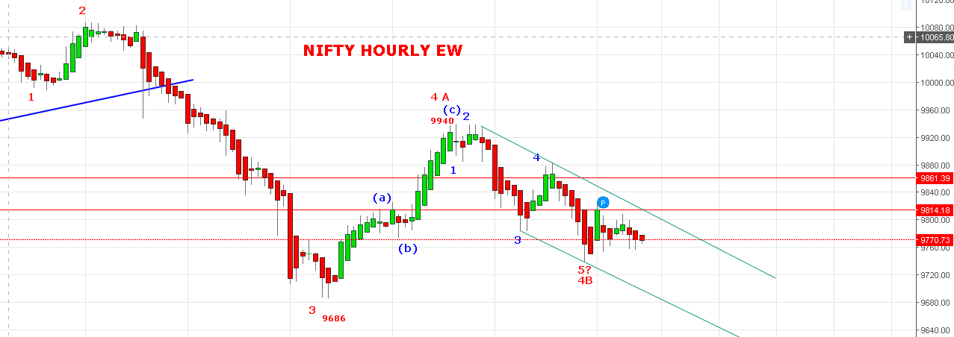

IF PRICE NOT FALLS BELOW 9740 TOMORROW AND MOVES ABOVE 9833 THEN IT WILL BE PART OF 4 WAVE (C) IN PROGRESS WHICH CAN TEST 9890-9940 LEVELS AGAIN.
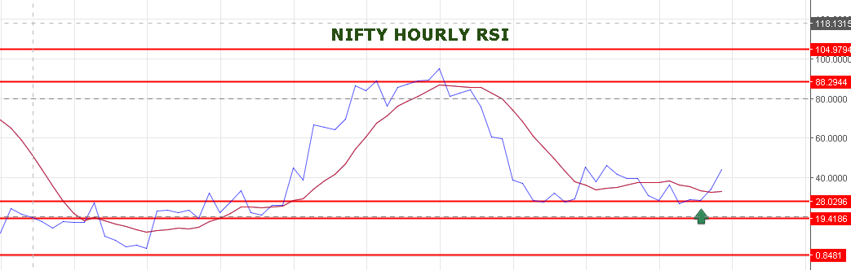
HOURLY RSI TURNED UP. EXPECTING GAP UP OPENING TOMORROW NEAR 9840 LEVELS.

BUY ABOVE 9833NS AND SELL BELOW 9800 NS WILL BE THE STATEGY TOMORROW.

TODAY’S TRADE:
SHORT IN 9900PE @122 AND BOOKED PROFIT @109= PROFIT 13 POINTS.
SHORT IN NF @9823 AND BOOKED PROFIT @9779= PROFIT 44 POINTS.
BOUGHT 9800PE @65 BOOK PROFIT @80= PROFIT 15 POINTS.
SHORT IN 9900PE @122 STOP OUT @127= LOSS OF 5 POINTS.
BOUGHT 9900PE @125 BOOK PROFIT @150= PROFIT 25 POINTS.
BOUGHT 9900PE @126.5 STOP OUT @116=LOSS OF 11.5 POINTS.
BOUGHT 9900PE @115 BOOK PROFIT @148=PROFIT OF 33 POINTS.
BOUGHT 9900PE @143 STOP OUT @133= LOSS OF 10 POINTS.
BOUGHT 9800CE @72.5 STOP OUT @66= LOSS OF 6.5 POINTS.
BOUGHT 9900PE @135 BOOK PROFIT @148= PROFIT OF 13 POINTS.
TOTAL PROFIT IN OPTION=66 POINTS. NF=44 POINTS. NET=110 POINTS.
TOMORROW’S TRADE:
BUY NF IF NS SUSTAIN ABOVE 9833 STOP 9800NS FOR TARGET 9875-9920 LEVELS.
SHORT NF IF NS REMAINS BELOW 9798 LEVEL FOR TARGETS 9740-9650 STOP 9833NS.
BUY 9800CE @92+ STOP 82 TARGETS 108-119-133.
BUY 9800PE @103+ STOP 91 TARGETS 116-124-136.

