**NIFTY PREDICTION FOR 10/09/2017:**

**NIFTY HOLDING BELOW 9930 WILL MOVE TOWARDS 9795 LEVELS.**

**SAR: 10037NS.**

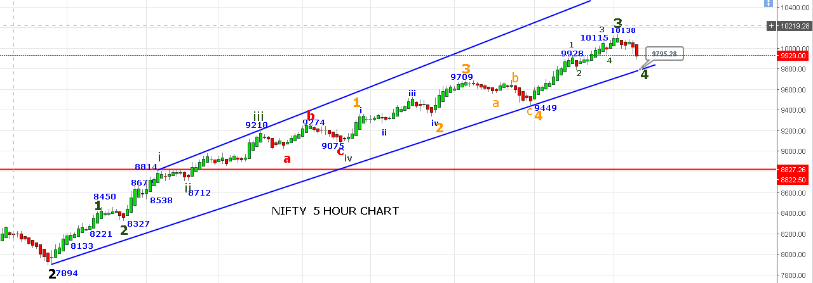

**AS PER ABOVE CHART REVERSAL ONLY ABOVE 10040NS. BOTTOM CHANNEL IS @9795 IF 9760 LEVELS BROKEN THEN DEEPER CORRECTION EXPECTED.**

**BUY ZONE 9765-9800 LEVELS FOR 10500+.**

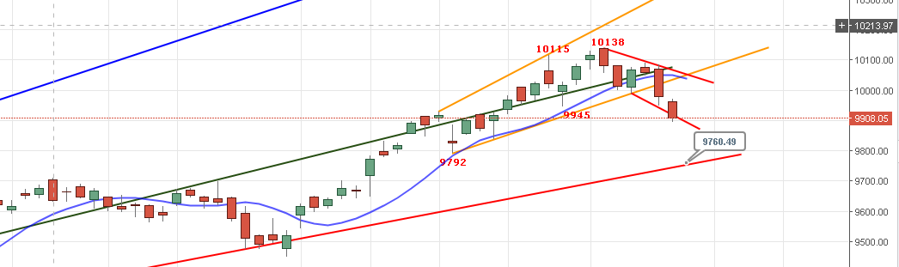

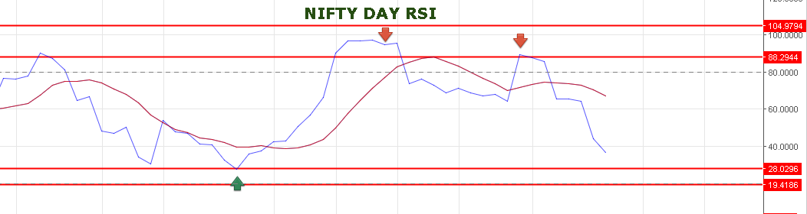

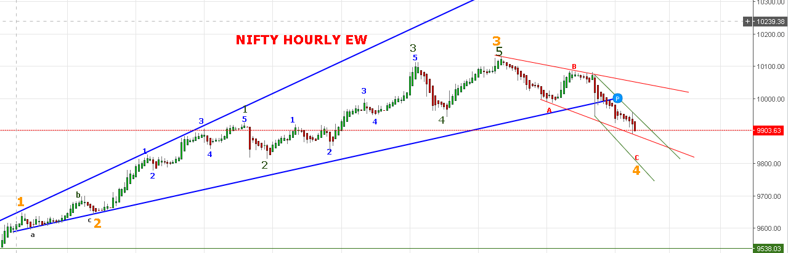

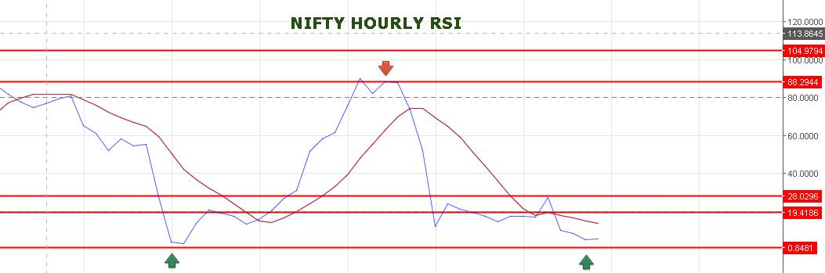

**IF PRICE ABLE TO HOLD 9888 LEVELS TOMORROW THEN STRONG UPMOVE WILL SEE BREAKING ABOVE 9940 TOWARDS 10045NS. BREAK OF 9880 LEVELS WILL SEE QUICK FALL UP TO 9795-9760 LEVELS.**

**TODAY’S TRADE:**

**BOOKED PROFIT IN NF @9958 SHORT TAKEN @10030NF.**

**SHORT TAKEN @9975NF COVER @9942.**

**SHORT TAKEN @9962NF COVER @9932 & 9920NF.**

**NO POSITION IN NF NOW.**

**BOOKED PROFIT IN 10000PE @124 TAKEN @108.**

**10300CE STOP OUT @11 TAKEN @13.**

**BOUGHT 10100CE @56 STOP OUT @50.**

**BOUGHT 10000PE @123 BOOK PROFIT @140.**

**BOUGHT 10100CE @47 BOOK PROFIT @55.**

**BOUGHT 10000PE@130 BOOK PROFIT @149.5.**

**NO POSITION IN OPTION NOW.**

**TOMORROW’S TRADE:**

**POSITIONAL BUY ONLY ABOVE 9995 NS OR NEAR 9760 TO 9800 LEVELS WITH STOP 9750NS.**

**BUY NF @9955 STOP 9940 TARGETS 9967-9978-9999.**

**SHORT NF @9907 STOP 9927 TARGETS 9886-9875<9850<9830<9819.**

**BUY 10100CE @50-52 STOP 48 TARGETS 57-63-72-91.**

**BUY 10000PE @155 STOP 141 TARGETS 165-173-191-204-220.**

**PRICE CAN MOVE SIDEWAYS 9916 TO 9841NS.**