BANK NIFTY PREDICTION FOR 29/08/2017:
BANK NIFTY FORMS DOJI BUT HOLDING ABOVE 24200BNS.
SAR: 24164BNS.
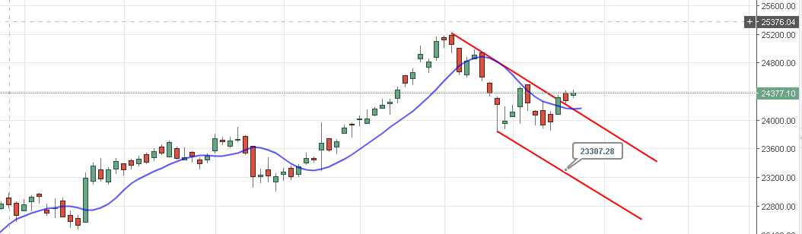
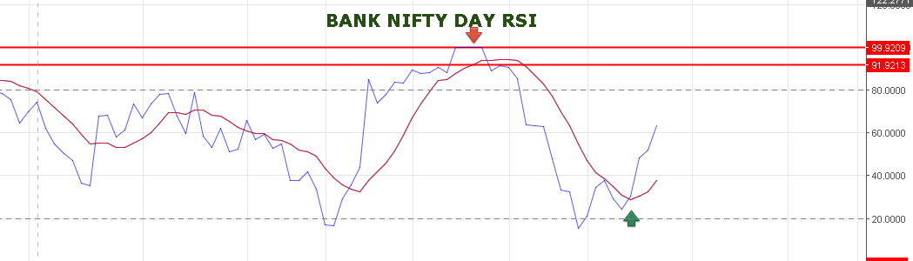
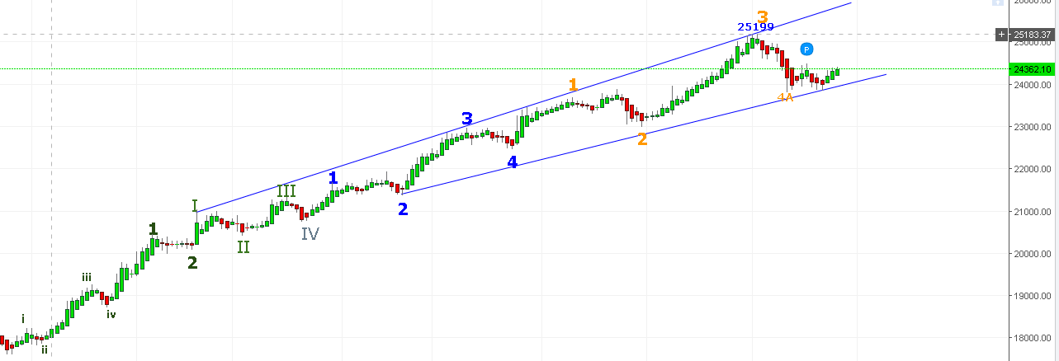
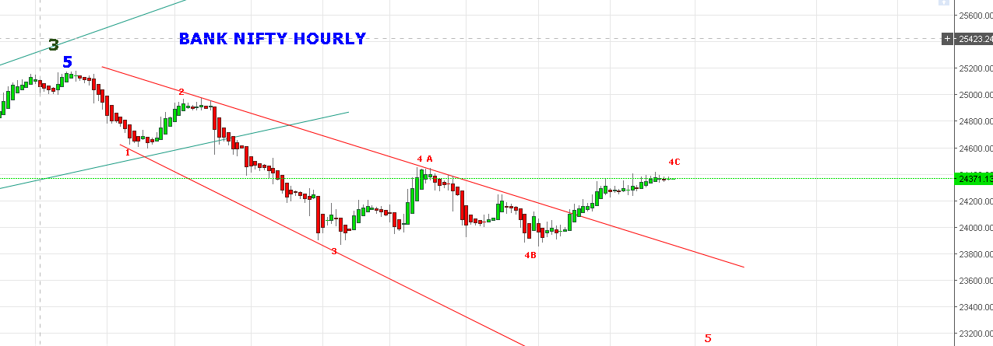
WE ARE HOLDING SHORTS STOP 24420BNS TARGETS 24060-23850BNS.
BUY ABOVE 24440BNS TARGETS 24500-24550BNS.
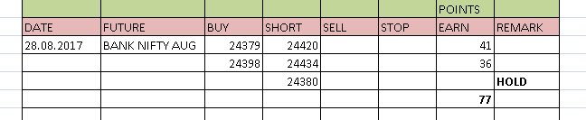

BUY BNF @24450 STOP 24400 TARGETS 24490-24520-24560.

