NIFTY PREDICTION FOR 31/07/2017:
NIFTY HOLDING 10000 LEVEL AFTER MAKING LOW 9945.
SAR: 9951NS.
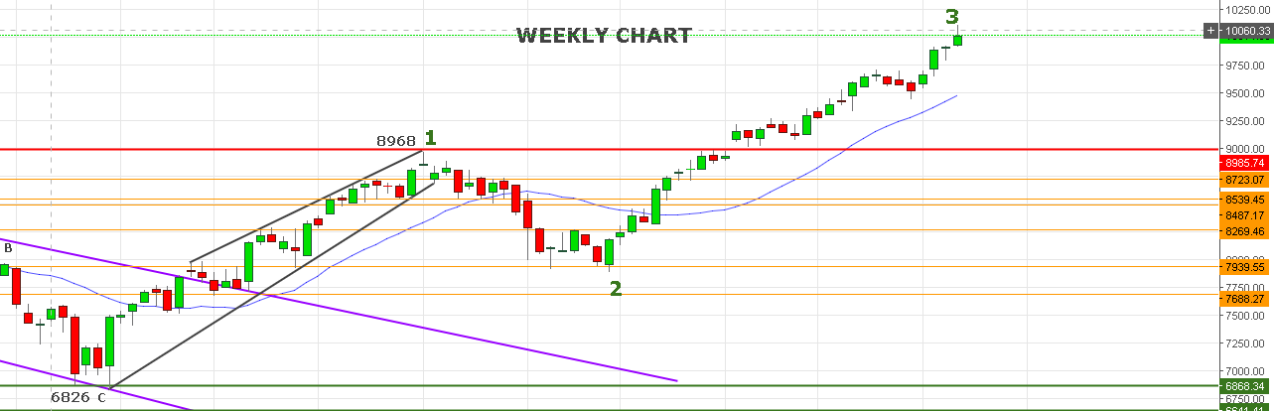
IT WAS A POSITIVE WEEK FOR NIFTY HIGH MADE 10115 AND FALL 170 POINTS BUT ABLE TO CLOSE ABOVE 10000 MARK. WEEKLY LOW WAS 9919.6 AND THAT IS THE POINT OF REVERSAL IF CLOSED BELOW IN COMING WEEK.
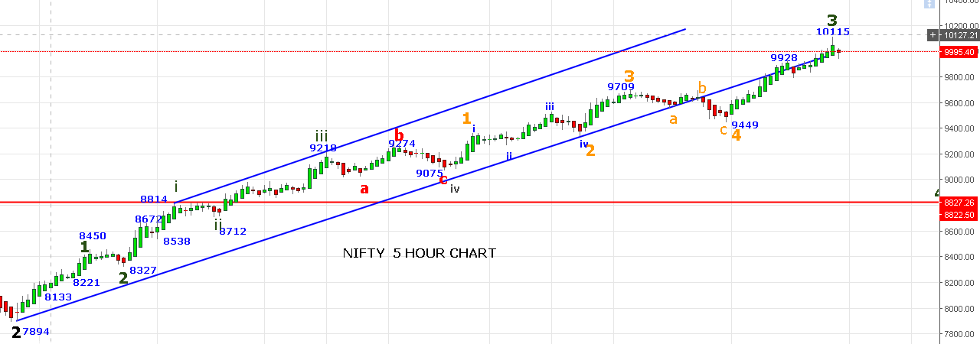
HANGING MAN PATTERN FORMS NEXT CANDLE SHOULD BE BIG RED.
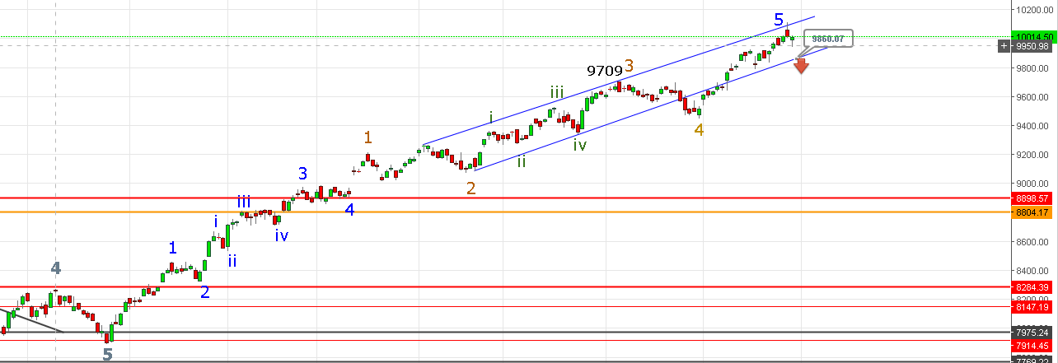
PRICE MUST BREAK 9860 LEVEL TO CONFIRM END OF FIRST WAVE STARTED FROM 7894 LEVELS.
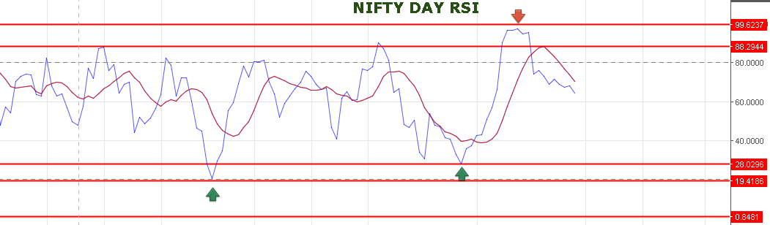
DAILY RSI MOVING TO SOUTHWARD DIRECTION.
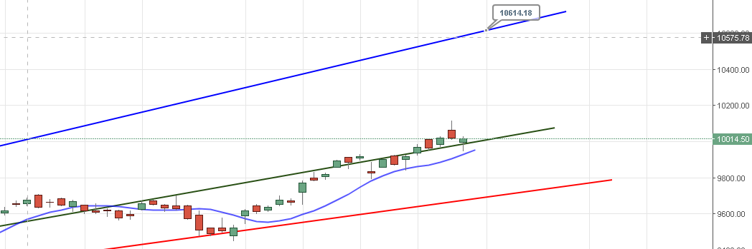

PRICE IS HOLDING ABOVE GREEN CHANNEL FOR MOVE TOWARDS 10600 LEVELS.
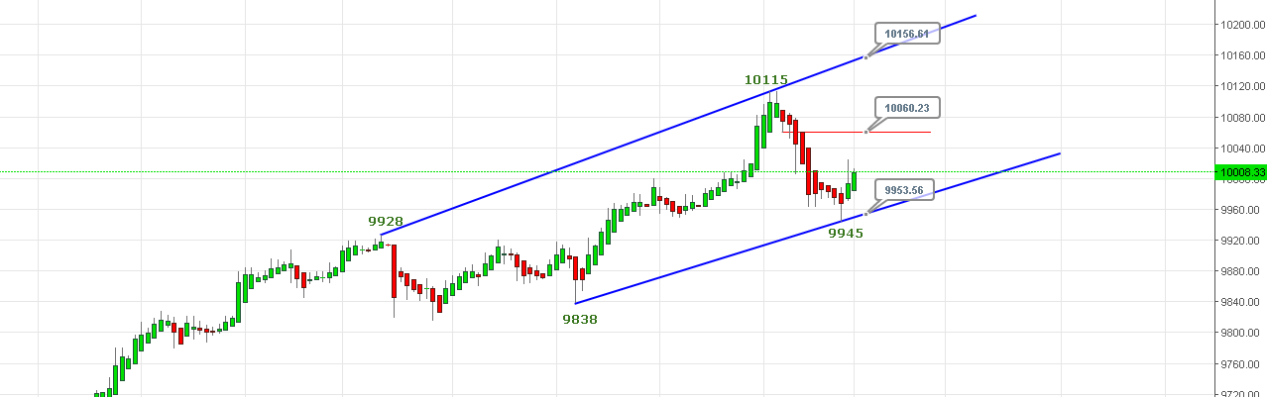

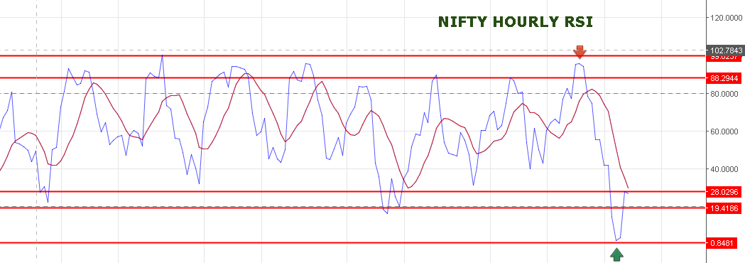

IF PRICE BREAK ABOVE 10060 TARGETS 10157NS.IF PRICE FALL WITHOUT BREAKING 10040-50 THEN WE CAN SEE 9955 LEVEL AGAIN. BREAK OF 9945 WE CAN SEE FALL UP TO 9920-9909 LEVEL. 9900 IS A GOOD SUPPORT IF THAT BROKEN THEN NEXT SUPPORT WILL BE 9860<9838.
SHORT NS NEAR 10025-10050 STOP 10060 TARGETS 9955-9920-9909.
BUY NS ABOVE 10060NS TARGETS 10157-10188-10230-10275NS STOP 10030NS.
OPTION:
BUY 10100CE @ 105 STOP 91 TARGETS 120-127-137. SHORT @79 STOP 87 TARGETS 66-59-49.
BUY 10000PE @110+ STOP 102 TARGETS 118-125-137-145-156. SHORT @ 87 STOP 95 TARGETS 67-56.

