NIFTY PREDICTION FOR 25/07/2017:
NIFTY ABLE TO BREAK 9930 AND DID 9982 CLOSER TO 10000 LEVEL.
SAR: 9870NS.

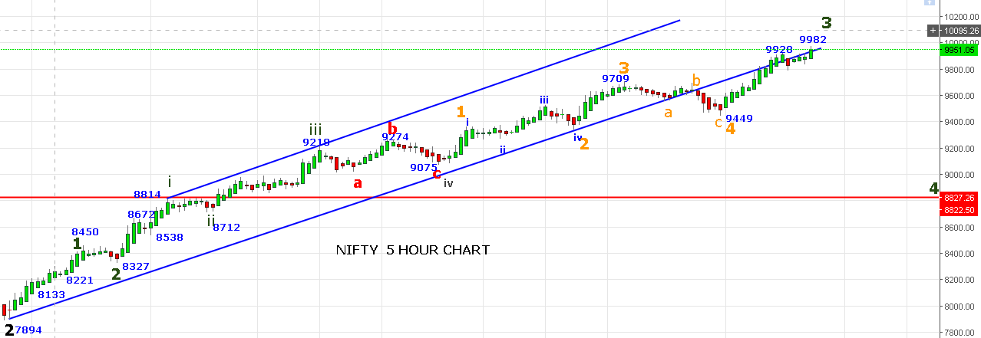
AS LONG PRICE HOLDING ABOVE 9888 RALLY WILL CONTINUE.
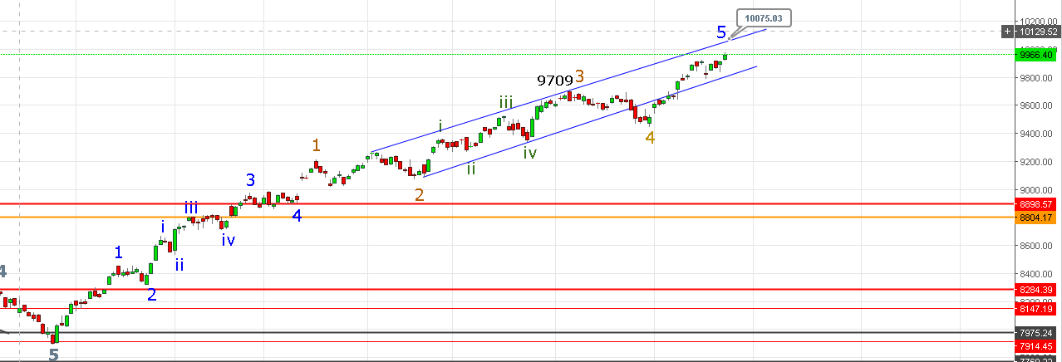
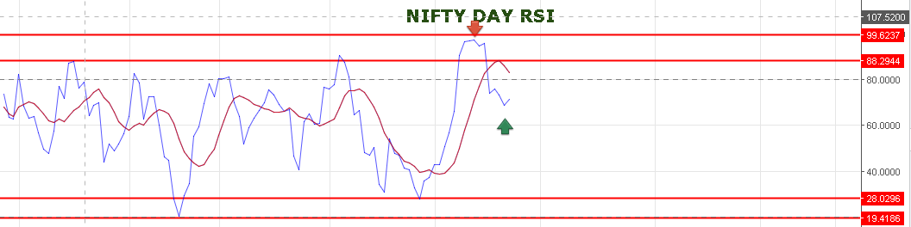
DAY RSI TURNED UP.
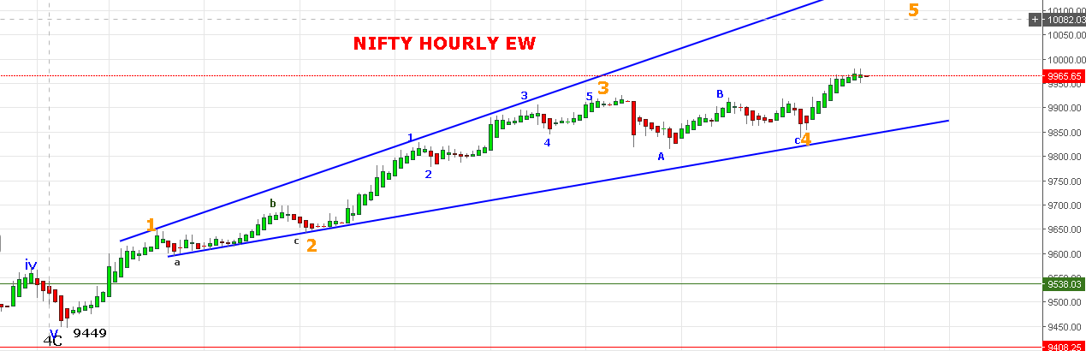

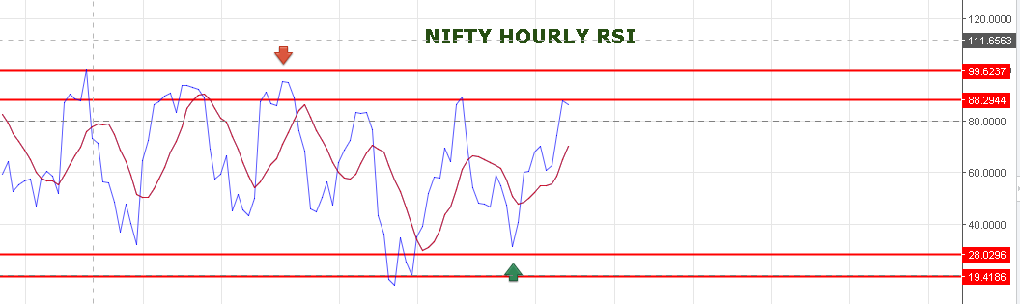
HOURLY RSI SLIGHTLY TURNING.
FIBO RETACEMENT 9838 TO 9982: 23.6%=9948 & 38.2%=9927.
WE CAN EXPECT 9927 IF PRICE BREAK 9948NS. ABOVE 9982 TARGETS 10031-10080.
BEARISH BELOW 9900NS FOR 9790-9690 LEVELS.
TODAY’S TRADE:
WE BOOK PART PROFIT @9946NF HOLDING LONG FROM FRIDAY @9902NF REST HOLD WITH STOP 9925NF.
BOOK PART PROFIT IN 10000 AUGUST CE @130 TAKEN @97 ON FRIDAY REST HOLD WITH STOP 113.
BOUGHT 9800JULY CE @ 133 BOOK PROFIT @ 173.
BOUGHT 10000PE @73+65 STOP OUT @60. REENTER @65 AND HOLD.

