**NIFTY PREDICTION FOR 24/07/2017:**

**NIFTY FORMS HANGING MAN IN WEEKLY CHART. WILL NIFTY SEE 10000 LEVELS?**

**SAR: 9860NS.**

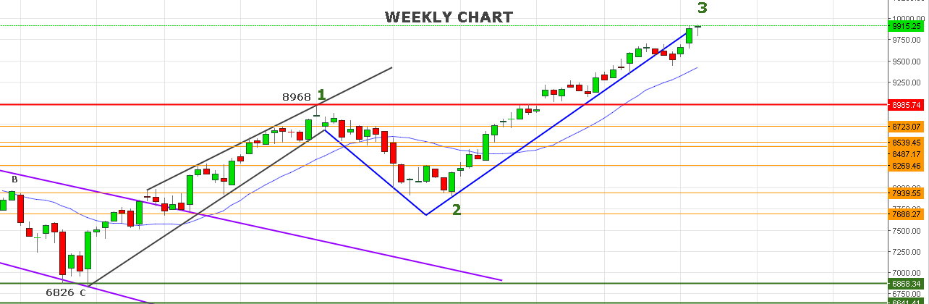

**HANGING MAN CANDLE STICK IN MAKINIG OF EVENING STAR WILL CONFIRM BY FORMATION OF BIG RED CANDLE.**

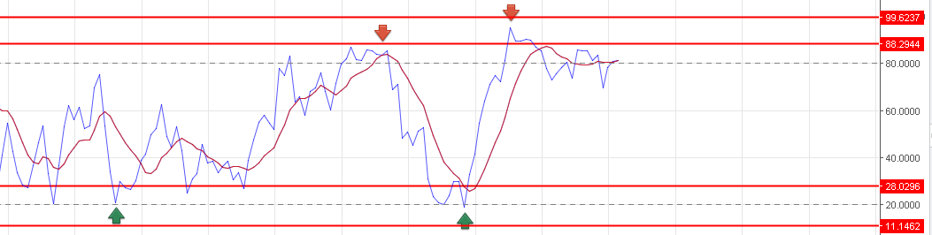

**WEEKLY RSI IS NOW BENDING.**

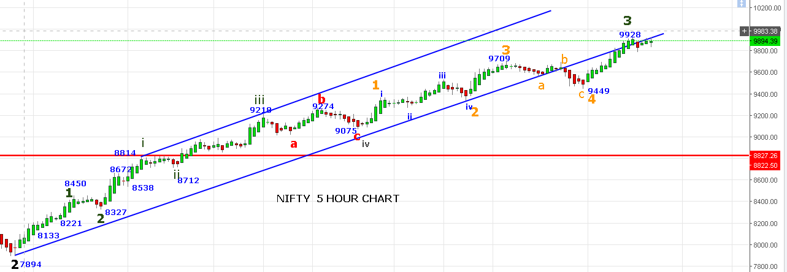

**LAST FOUR TRADING SESSIONS PRICE MOVED IN SIDEWAYS FROM 9815 TO 9928 . BREAKING EITHER SIDE CAN SEE BREAKDOWN OR BREAKOUT MOVE. SINCE 9930 NOT YET TAKEN OUT STILL BEARS ARE ALIVE TO TAKE PRICE BELOW 9800.**

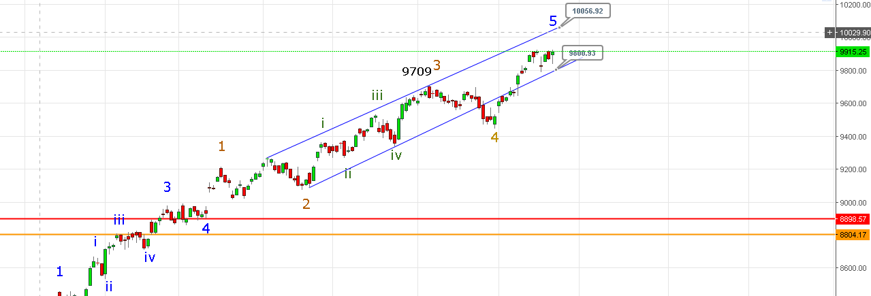

**AS LONG PRICE HOLDING IN THE CHANNEL BULLS ARE UNDERCONTROL. BREAKOUT ABOVE 9931 CAN SEE 9998 TO 10034-10056 LEVELS.**

**BELOW 9830/9800 CAN SEE 9765-9745-9709-9690-9677NS.**

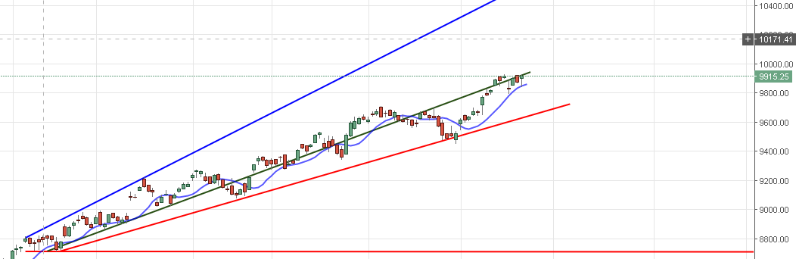

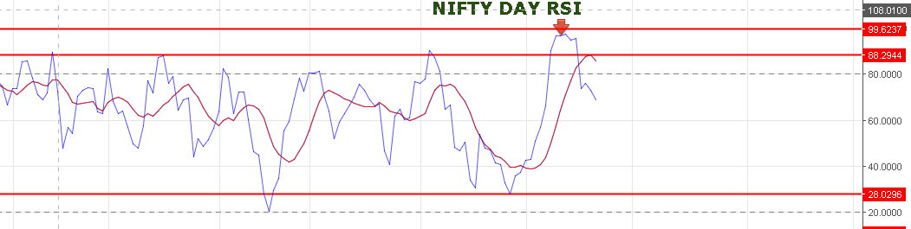

**DAY RSI BREAKDOWN AND FALLING.**

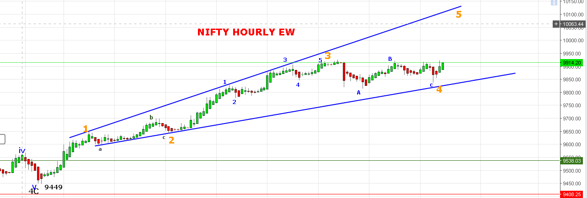

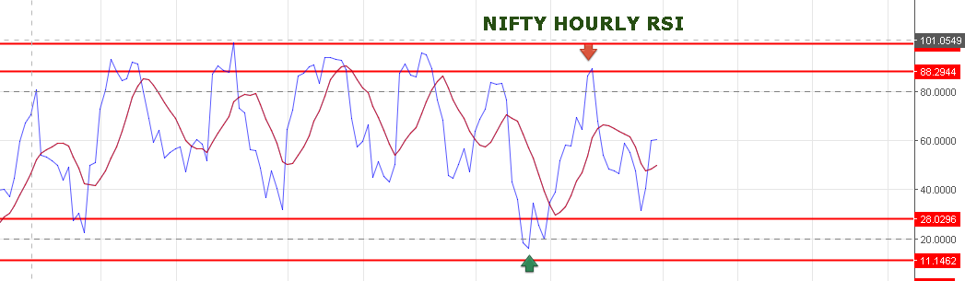

**HOURLY RSI NEUTRAL NOW CAN MOVE ANY SIDE.**

**HOURLY SAR: 9888NS. DAY PIVOT: 9893NS.**

**RESISTANCE: 9930-9947-9979-9998.**

**SUPPORT: 9891-9876-9830-9790.**

**MOST PROBABLY WE HAVE DONE 4TH WAVE IN A ROLLER-COASTER WAY 9928-9813-9922-9838 AND 5TH WAVE STARTED FROM 9838NS.**

**CHART GIVEN BELOW IS 15MINT CHART SHOWING 9950 IS THE RESISTANCE CHANNEL ON UPPER BAND AND 9895 ON LOWER BAND BREAK BELOW WE WILL SEE 9827 LEVELS.**

**IF PRICE FALL WITHOUT BREAKING 9930 WE CAN SEE SHARP FALL BELOW 9860 LEVELS.**

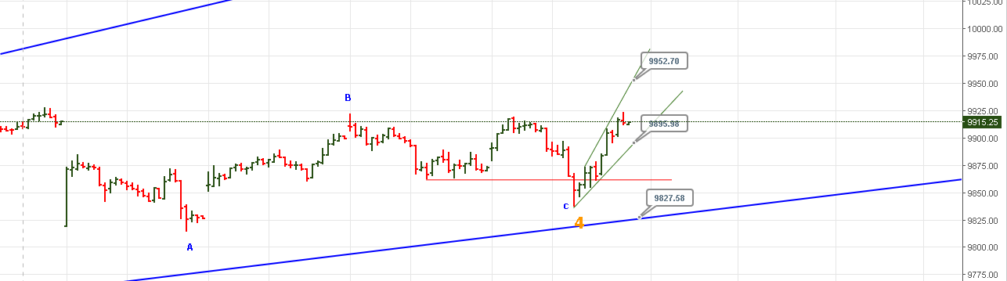

**RED LINE MARKING AS SUPPORT NEAR 9860 IF PRICE CROSS 9930 FIRST AND THEN FALL WE MUST ADD LONG WITH STOP 9860 ON HOURLY BASIS.**

**FRIDAY’S TRADE:**

**WE TAKEN SHORT @9885NF AND STOP OUT @9910NF= LOSS 25 POINTS.**

**TAKEN SHORT @9912 NF AND BOOK PROFIT @9840= PROFIT 72 POINTS.**

**TAKEN SHORT @9878 AND STOP OUT @9900= LOSS 22 POINTS. NET INTRADAY PROFIT=25 POINTS.**

**HOLDING LONG @9902NF. TARGET 9988-10005-10040 NF.**

**OPTIONS:**

**BOUGHT 10000PE @ 124 STOP OUT @ 111= LOSS 13 POINTS.**

**BOUGHT 10000PE @108 BOOK PROFIT @160=52 POINTS.**

**BOUGHT 9800CE @108 BOOK PROFIT @124=16 POINTS.**

**SHORT 9800CE@ 129 BOOK PROFIT @108=21 POINTS.**

**BOUGHT 10000PE@ 127 STOP OUT @119=LOSS 8 POINTS.**

**BOUGHT 9800CE @108 STOP OUT @103= LOSS 5 POINTS.**

**NET INTRADAY PROFIT IN OPTION=63 POINTS.**

**HOLDING 10000 AUGUST CE @97. TARGETS 114-137-146-157.**

**BUY 10000PE IF NS TRADE BELOW 9895NS. OR BUY @115-120 TARGETS 132-141-152.**