**NIFTY PREDICTION FOR 17/07/2017:**

**NIFTY READY TO HIT 10000 LEVELS.**

**SAR: 9746NS.**

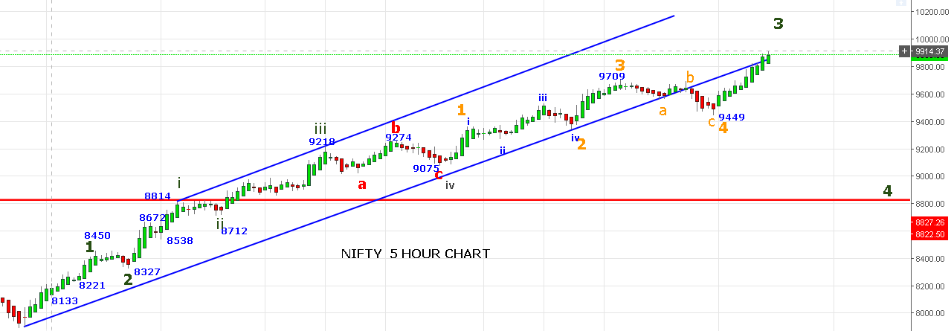

**REVERSAL ONLY BELOW 9825NS TILL THEN ENJOY THE RALLY. DUE TO STRONG PRICE ACTION I HAVE CHANGED THE EW COUNT.**

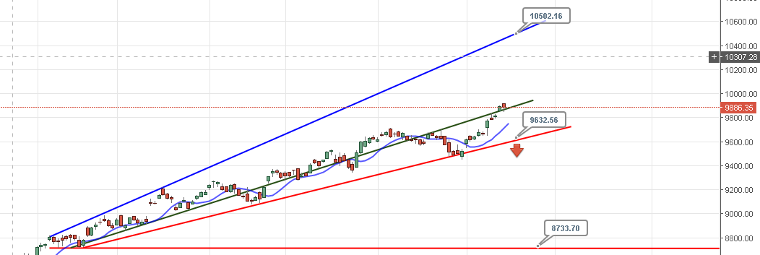

**PRICE NOW ABLE TO HOLD ABOVE GREEN LINE AND HEADING TOWARDS 10500 LEVELS IN COMING DAYS.**

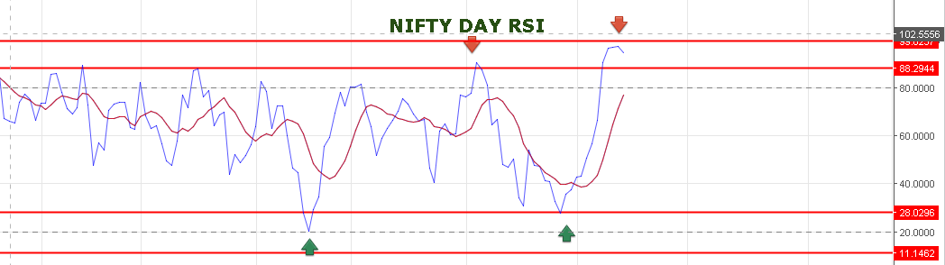

**DAY RSI IS TRADING @95 AND TURNING SLIGHTLY DOWN. REMAIN CAUTION AT HIGHER LEVEL.**

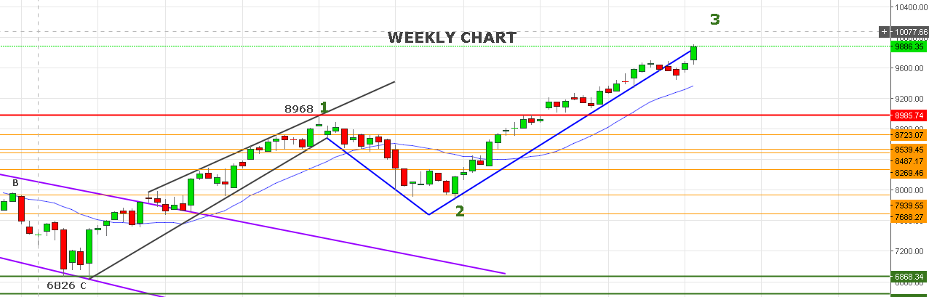

**IT WAS A POSITIVE WEEK PRICE ALMOST RUNS UP TO 200 POINTS AND NO SIGN OF WEAKNESS YET.**

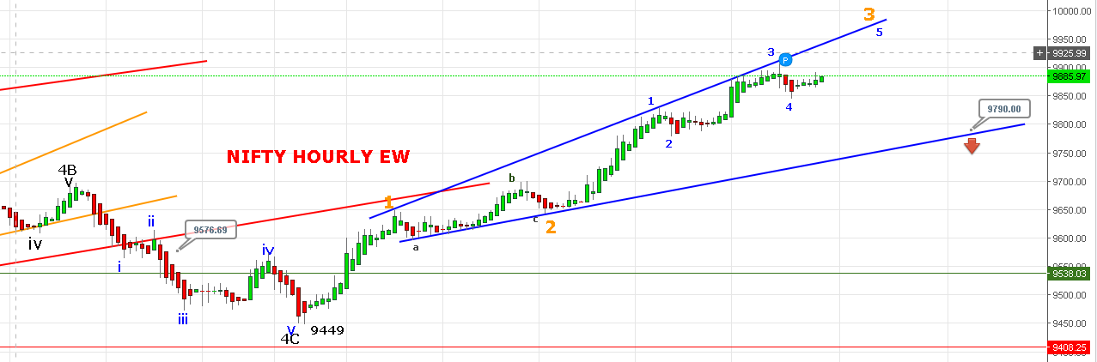

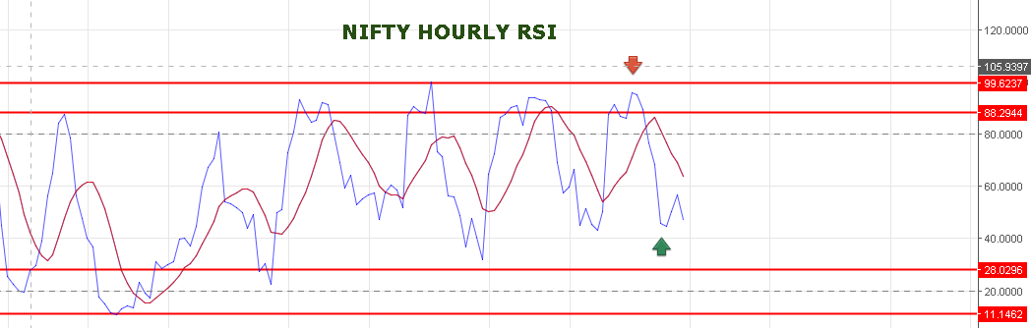

**WAVE 3 PROJECTING NEAR 9981 TO 10116 RANGE.**

**WE BOOKED OUR SHORTS NEAR 9850NS AND HOLDING LONG. BOOK PROFIT 9981 TO 10116 LEVELS.**

**RESISTANCE: 9925-9942-9960-9981-10000-10034.**

**WEAKNESS BELOW 9860NS & IF PRICE BREAK BELOW 9845 THEN WE CAN SEE 9827-9815 WILL ACT AS SUPPORT.**

**SHORT NF @9849 STOP 9879 TARGETS 9820-9750.**

**HOLD LONG WITH STOP 9850NF.**

**OPTION:**

**WE BOOKE PROFIT IN 10000PE @155.**

**BUY 10000PE @148+ STOP 138 TARGETS 162-173-186.**

**NOW HOLDING 9800CE @116. STOP 114 TARGETS 149-156-172-182-196.**