**NIFTY PREDICTION FOR 14/07/2017:**

**NIFTY CLOSED NEAR 9900 LEVEL HEADING TOWARDS 10030.**

**SAR: 9709NS.**

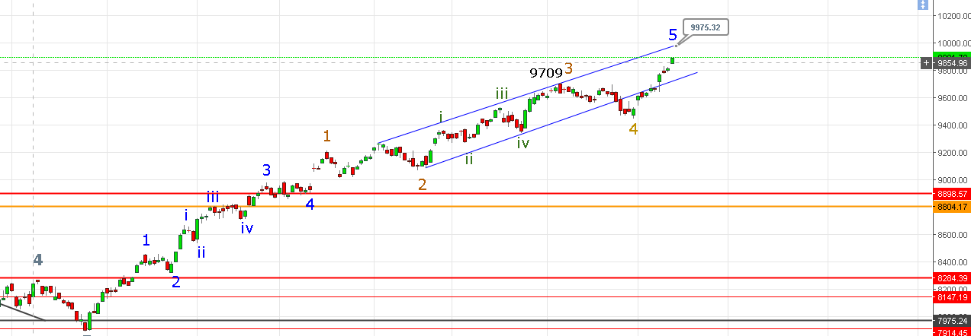

**IF PRICE ABLE TO SUSTAIN ABOVE 9898-9910 THEN NEXT TARGET IS 9925-9948-9975-10011-10034.**

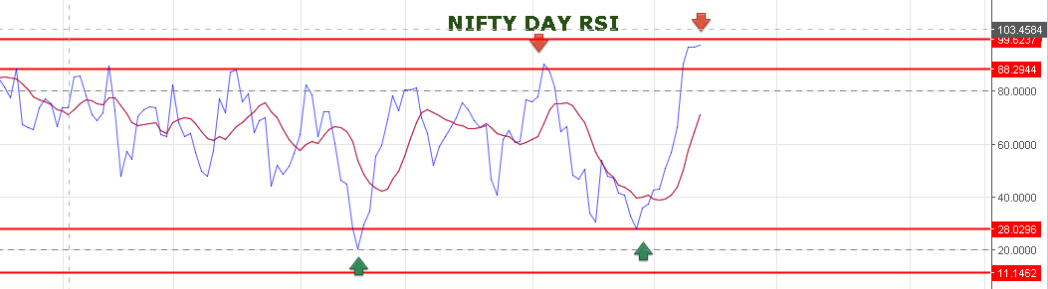

**DAY RSI AT OVERBOUGHT ZONE.**

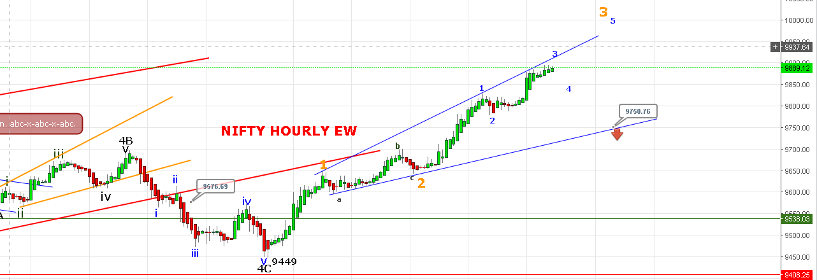

**I HAVE CHANGED THE EW COUNT AS PER PRICE ACTION. WE ARE IN 5(3)(3) WAVE. 5(4) AND 5(5) IS PENDING.**

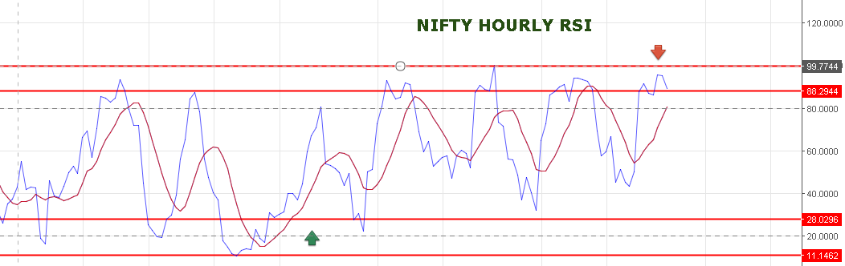

**WE BOOKED OUR LONG @9873NF. WE HAVE TAKEN SHORT @9890NF DUE TO TWO/THREE REASONS:**

1. **HOURLY RSI TURNED DOWN.**
2. **IN 30 MINT CHART CANDLE FORMS SHOOTING STAR.**

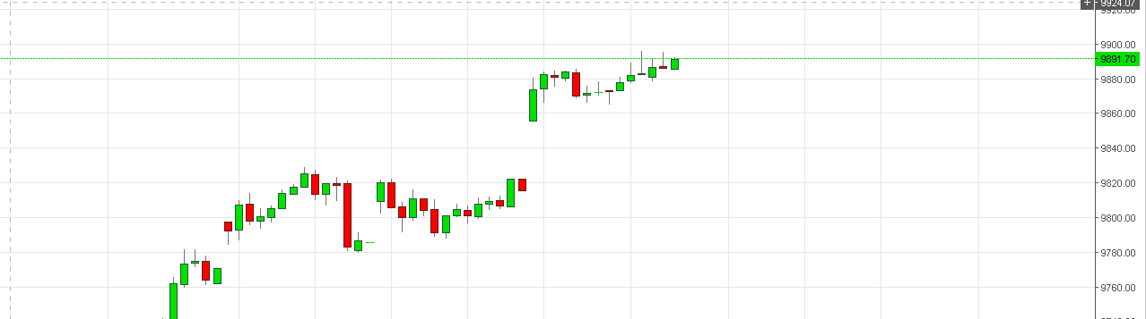

1. **MAY 5(3)(3) COMPLETE @9897 AND 5(4) WILL START.**

**IF FIRST 30 MINT. PRICE NOT ABLE TO CROSS 9898NS THEN WE CAN SEE 9860-9822 NS.**

**BOOK PROFIT HERE 9860-9822 AND GO LONG FOR 10030LEVEL.**

**IF PRICE ABLE TO CROSS ABOVE 9898 THEN NEXT RESISTANCE WILL BE 9908-9925-9948-9975-10034.**

**IF NF OPEN NEAR 9869 THEN TARGET IS 9849-9838.**

**BUY NF @ 9906 TARGET 9918-9926-9937. STOP 9892NF.**

**OPTION:**

**HOLDING 10000PE @139 STOP 9898NS. TARGET 148>158-165-182-193.**

**BUY 9800CE @132 STOP 122 TARGET 143-151-166-176-190.**