**NIFTY PREDICTION FOR 06/07/2017:**

**NIFTY MOVED SIDEWAYS IN NARROW RANGE PLAY.**

**SAR: 9561NS.**

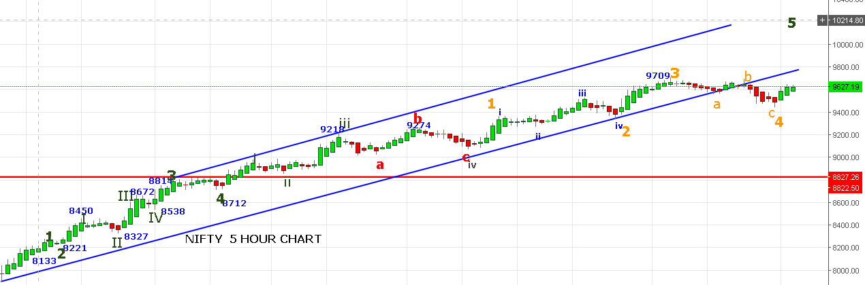

**REVERSAL ONLY BELOW 9587NS. TILL THEN UPSIDE REMAINS.**

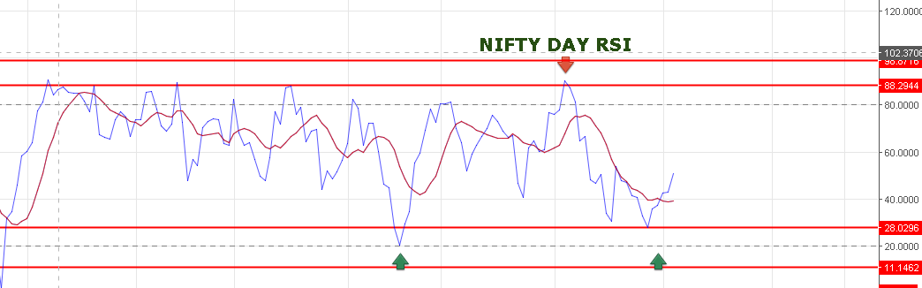

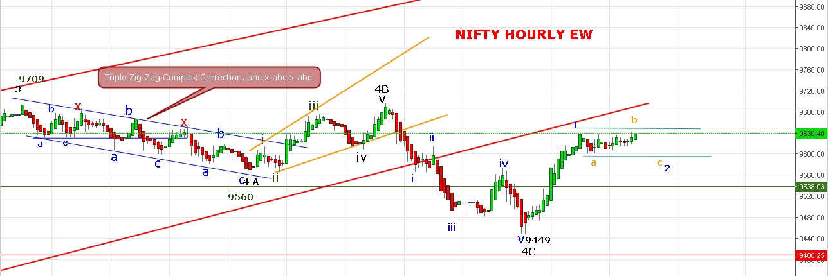

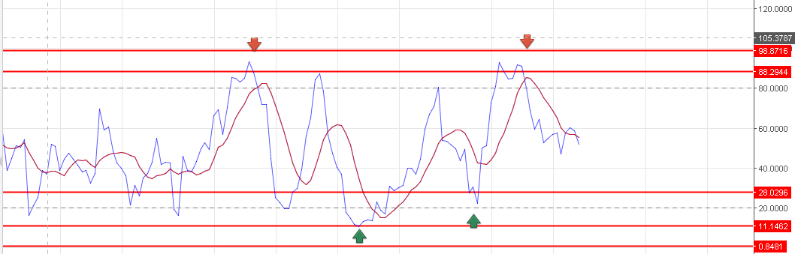

**SHORT NF @9633-9628 STOP 9638 TARGET 9618-9610-9601-9595.**

**BUY NF @9657-9662 STOP 9636 TARGET 9673-9680-9690.**

**BULLISH ABOVE 9655NS. WEAK BELOW 9607NS. BEARISH BELOW 9573NS.**

**RESISTANCE: 9655-9678.**

**OPTION:**

**BUY 9600PE @88-92 STOP 77 TARGET 100-106-114.**

**BUY 9600CE @122 STOP 113 TARGET 133-139-152-161.**