**NIFTY PREDICTION FOR 05/07/2017:**

**NIFTY FACE RESISTANCE @9650 BUT CLOSED ABOVE 9600 LEVEL.**

**SAR: 9555NS.**

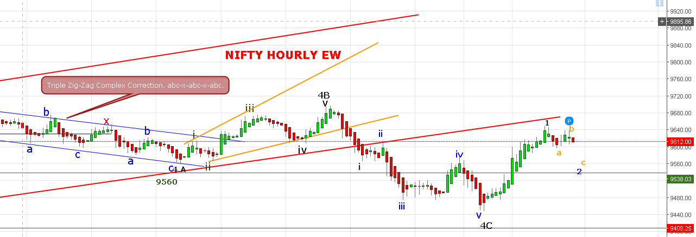

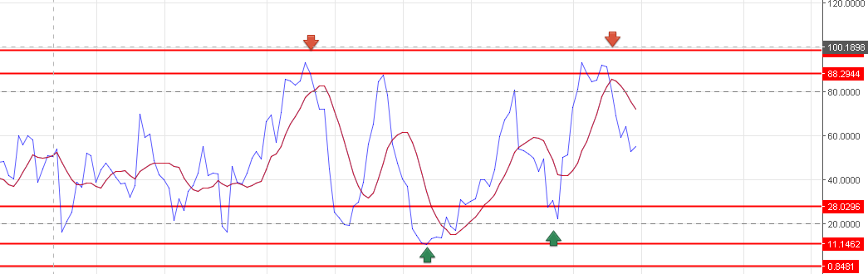

**NIFTY OPEN @9651 AND THAT WAS THE HIGH DURING THE DAY AND NOT ABLE TO SUSTAIN ABOVE IT. BY TOUCHING 9650 LEVEL PRICE CONFIRM IN ITS 5TH WAVE – PRICE RETRACE MORE THAN 75% OF 9709-9449. MOREOVER FALL FROM 9650 TO 9596 WAS NOT A 3RD WAVE CHARACTER, SO FLAT CORRECTION IN PROGRESS IN 5(2). FROM 9651 TO 9596=2(a) AND FROM 9596 TO 9640=2(b). WAVE 2c CAN GO UP TO 9573 TO 9550 LEVEL.**

**BELOW 9505NS WILL TAKE THE SHAPE OF 3RD WAVE AND ABOVE VIEW WILL NEGATE.**

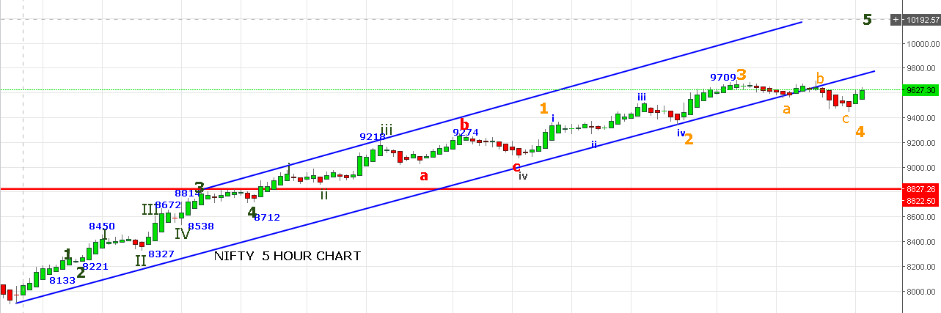

**REVERSAL ONLY IF CLOSED BELOW 9550 LEVEL.**

**SHORT NF @ 9612-9606 STOP 9621NF TARGET 9588-9578.**

**BUY NF @9637-9642 STOP 9613NF TARGET 9660-9670.**

**OPTION:**

**BUY 960OPE/9500PE IF TRADE BELOW 9601 STOP 9625NS. BOOK PROFIT NEAR 9570-9550.**

**BUY 9600CE IF NS TRADE ABOVE 9617NS STOP 9603NS. BOOK PROFIT NEAR 9640-9690NS.**