NIFTY PREDICTION FOR 30/06/2017:
MONTHLY CHART IN MAKING OF HAMMER TRADING BELOW PIVOT.
SAR:9593NS.
MONTH PIVOT: 9562NS.
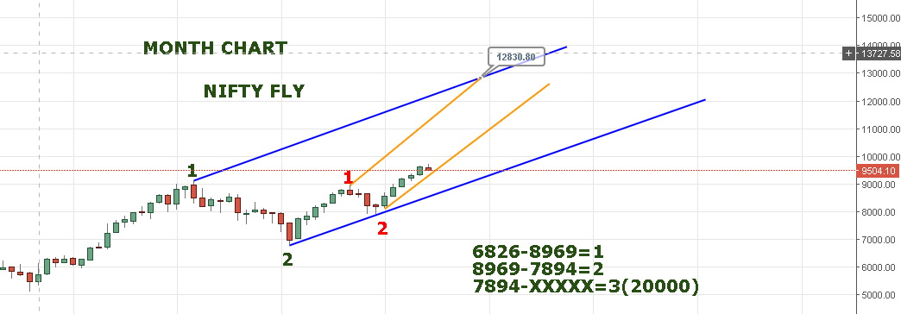
AFTER FIVE MONTH OF STRAIGHT GREEN CANDLE NOW FORMING HAMMER IN SIXTH MONTH.NIFTY NEED TO HOLD 9300 LEVEL ON CLOSING BASIS TO MAINTAIN THE BULL RUN.
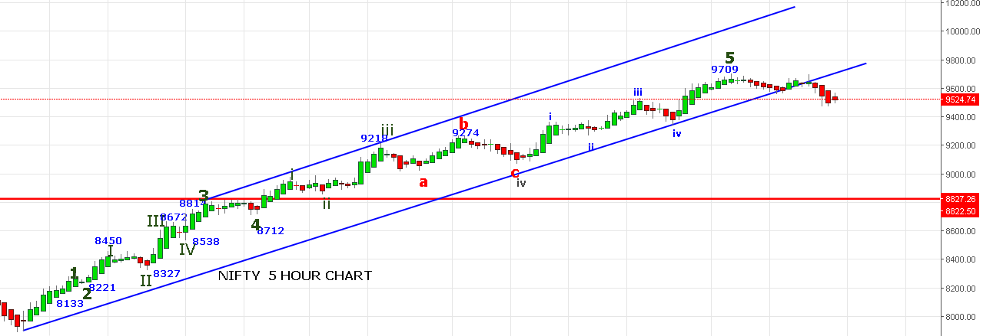
ABOVE CHART MAKES DOJI TODAY. TOMORROW TRADING ABOVE TODAYS HIGH 9575 WILL CAUSE PAUSE IN CORRECTION AND PRICE WILL HEADS TOWARDS 9850-10037.
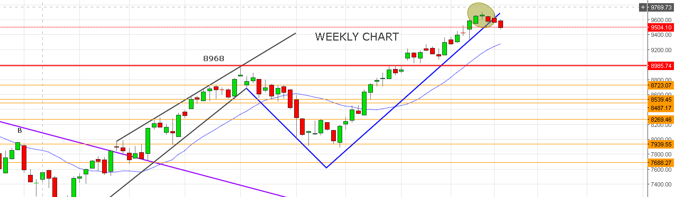
TOMORROW IS WEEKLY CLOSING AND CHART STILL LOOKS HIGHLY BEARISH TARGETING 9280 LEVEL IN COMING WEEKS.
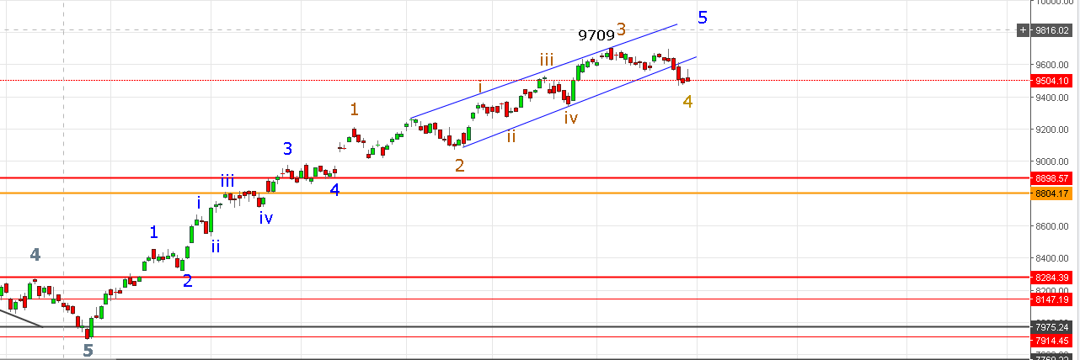
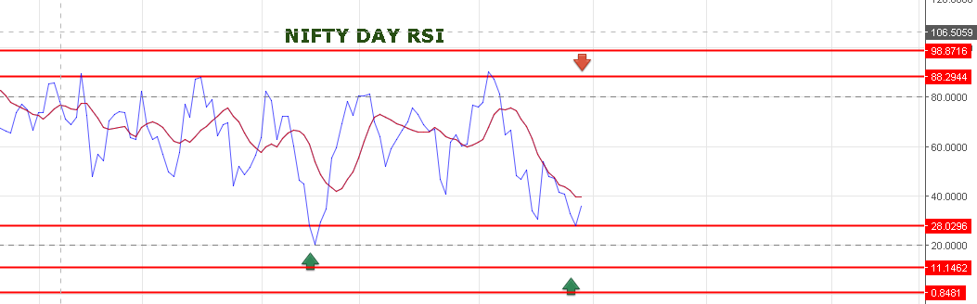
DAY RSI IS TURNNING UP BLUE LINE MUST CROSS AND CLOSE ABOVE IT FOR BULLISH.
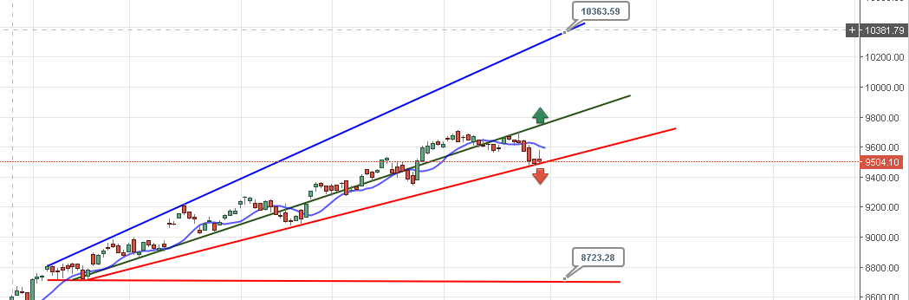
PRICE STILL HOLDING RED LINE AND CAN BOUNCE FOR 9730 LEVEL. BREACH OF RED LINE CAUSE MASSIVE SELLING AND PRICE CAN TOUCH 8725 LEVEL.
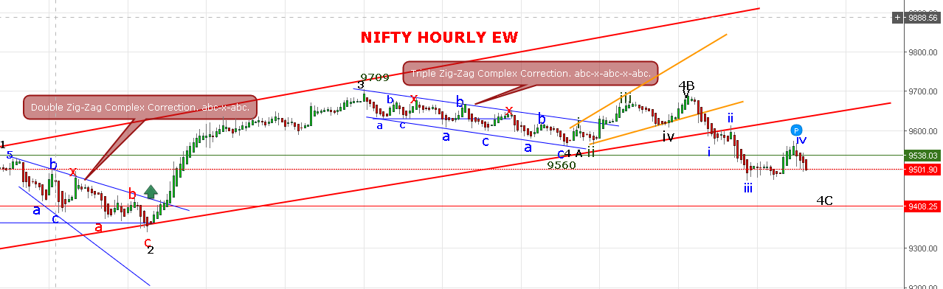
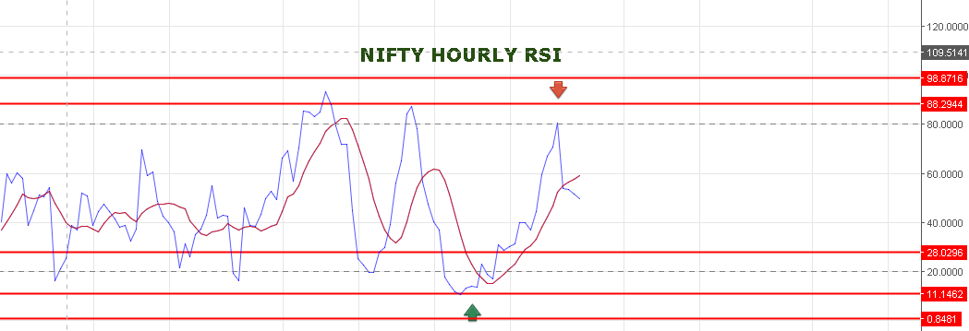
HOURLY RSI FALLING BUT SLIGHTLY TURNNING.
WE ARE STILL IN 4TH WAVE AND TODAY PRICE WAS RUNNING AT INNER WAVE (iv) AND (v) IS STILL PENDING. 4TH WAVE MUST BE OVER NEAR 9460-9435-9403. PRICE BREAKING BELOW 9373 WILL CONFIRM DOWN WARDS CORRECTION OF 3RD LARGER WAVE STARTING FROM 9709.

BULLISH VIEW AS PER EW:
7909=3.
7909 TO 9560=4A.
9560 TO 9699=4B.
9699 TO 94XX=4C. (RUNNING) AFTER IT 5TH WILL START FOR 10037.
BEARISH VIEW AS PER EW:
9709 TO 9560=1
9560 TO 9699=2
9699 TO 93XX=3.
BUY NF ONLY IF NS TRADE ABOVE 9555 STOP 9535NS.
SHORT NF IF NS TRADE BELOW 9494 STOP 9527NS.
NIFTY PIVOT @9525 NOT TRADING ABOVE IS WEAK AND TRADING ABOVE IS BULLISH SIGNAL.
TODAYS TRADE:
WE SHORT NF @ 9570 STOP OUT @9580.
BOUGHT NF@9583 AGAIN STOP OUT @9560.
SHORT NF@9545 BOOK PROFIT @9518NF.
BOUGHT 9300JULY PE@37 AND HOLDING.
BOUGHT 9450JUNE CE@83 SOLD @120.
BOUGHT 9800 JUNE PE @241 SOLD @285.
OPTION FOR 30/06/2017:
HOLD 9300PE STOP 9527NS BOOK PROFIT NEAR 9435-9460.
BUY 9800CE IF ONLY IF TRADE ABOVE 9540NS STOP 9527NS.

