NIFTY PREDICTION FOR 28/06/2017:
NIFTY BROKEN 9560 LEVEL MAKES WEEKLY CHART BEARISH.
SAR:9624NS.
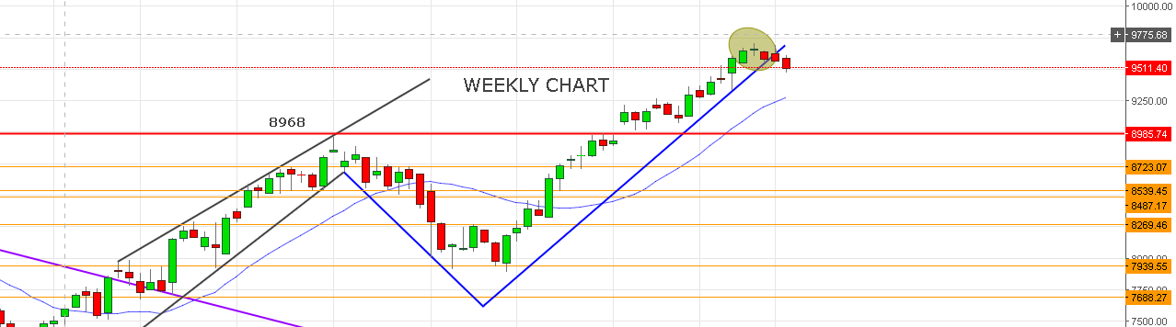
WEEKLY CHART SUGGESTING PRICE MOVING TOWARDS SUPPORT NEAR 9280 LEVEL.
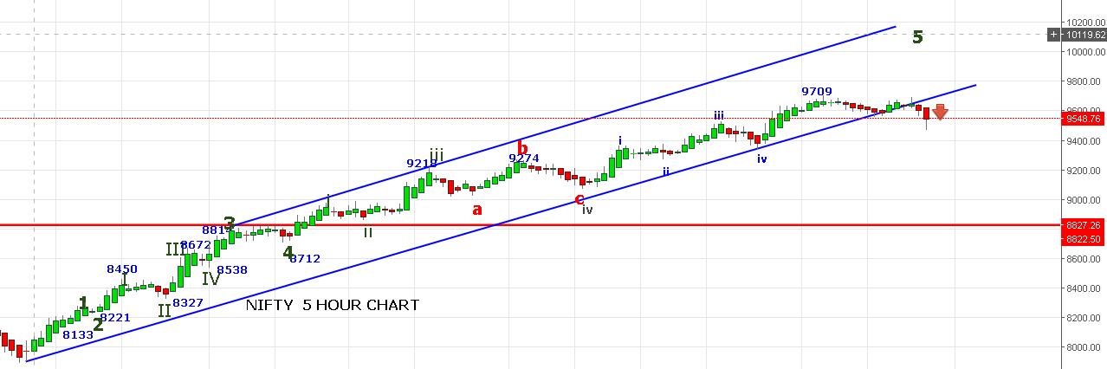
AS PER ABOVE CHART SELL SIGNAL CONTINUE AS LONG PRICE NOT CLOSED ABOVE 9626 LEVEL. TILL THEN SELL ON EVERY RISE .
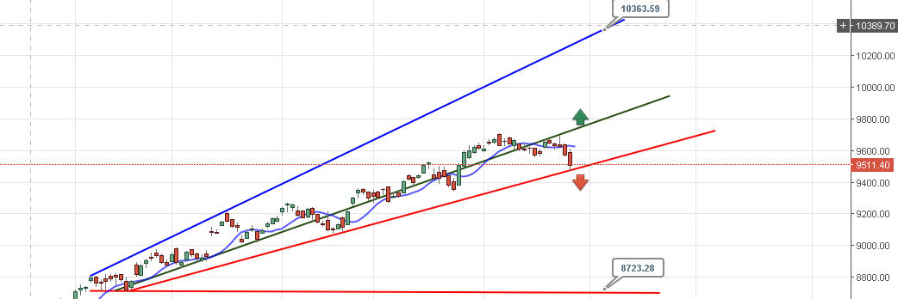
IF PRICE BREAK RED LINE THEN MASSIVE FALL UP TO 8724.IF ABLE TO HOLD 9460 LEVEL THEN WE CAN SEE 9730 LEVEL SOON.
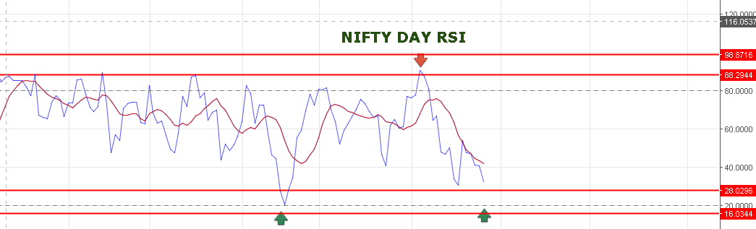
DAY RSI IS FALLING AND NEAR TO OVERSOLD ZONE. 9430-9410NS COULD BE POSSIBLE IF 9460 BREACH.
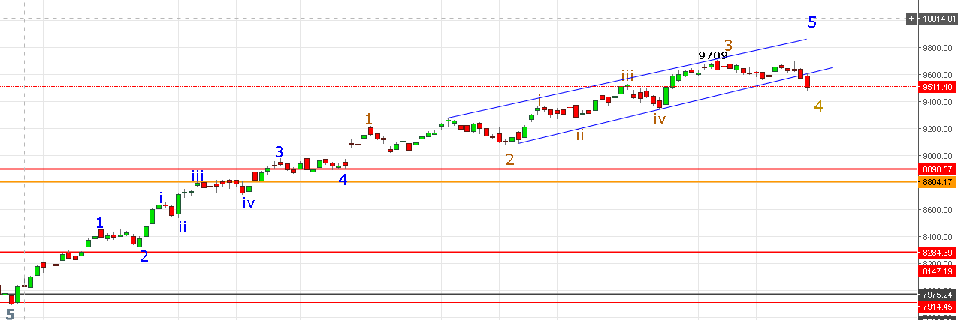
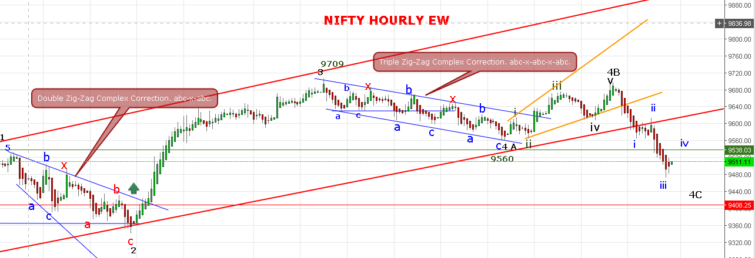
AS PER EW:
4TH WAVE MUST END NEAR 9460 TO 9430.
IF GOES BELOW 9408 THEN WE WILL CONSIDERED IT AS LARGER 3RD DOWN IN PROGRESS.
9709-9560=1. 9560 TO 9699=2. 9699 TO 92XX =3 IN PROGRESS.

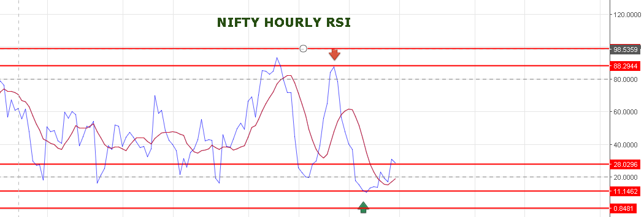TODAY WE EXIT OUR LONG @9603NF AT COST AND SHORT NF@9600 AND BOOKED PART NEAR 9540-9517-9500. NO POSITION NOW.
SHORT JULY NF IF OPEN NEAR 9540-9570 LEVEL STOP 9580NF OR= 9560 NS.TARGET 9440-9375NS.
BUY JULY NF IF NIFTY SPOT SUSTAIN ABOVE OR OPEN ABOVE 9560NS FOR TARGET 9730NS STOP 9550NS.
OPTION:
WE BOOKED 9800JUNE PE @305.
BUY 9800 JUNE PE IF PRICE TRADE BELOW 9490 STOP 9511NS.
BUY 9800CE JULY IF NS TRADE ABOVE 9530 STOP 9510NS.

