NIFTY PREDICTION FOR 27/06/2017:
TECHNICALS FAVOURING BEARS, BUT BULLS STILL ALIVE ABOVE 9560NS.
SAR:9629NS.
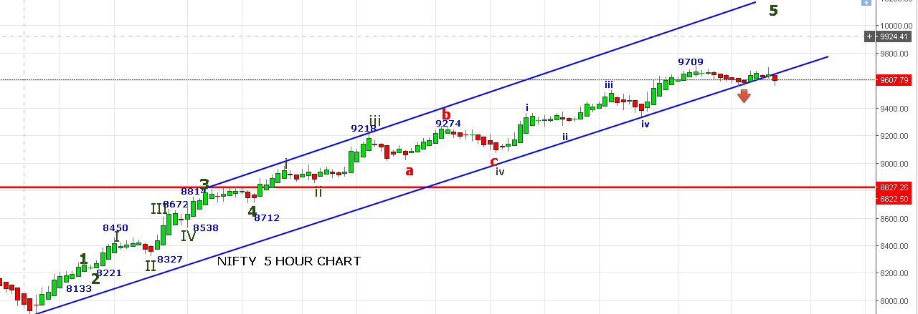
AFTER LONG TIME PRICE BROKEN THE CHANNEL AND CLOSED BELOW IT IN RED.BELOW 9550 HEADING TOWARDS 9480-9430-9375 LEVEL.
EXIT ALL LONG POSITION IF NOT ABLE TO TRADE ABOVE 9629 ON TUESDAY.
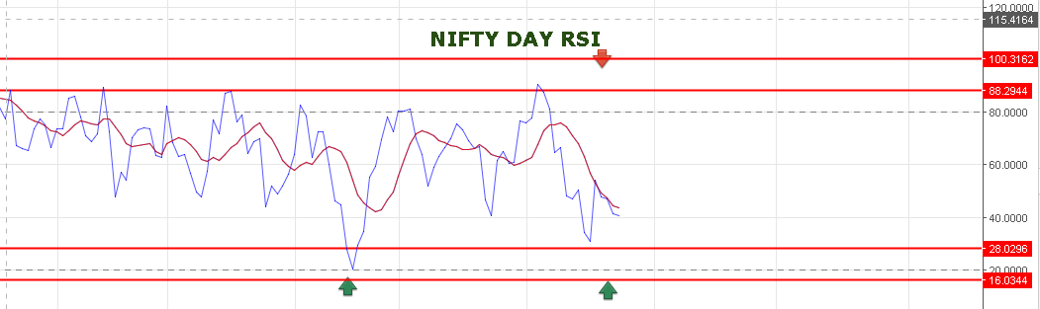
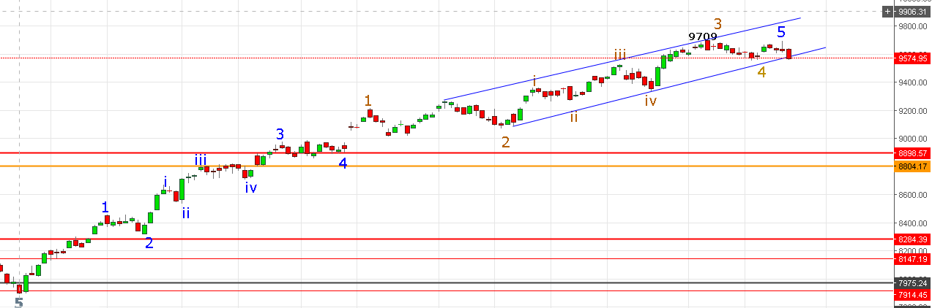
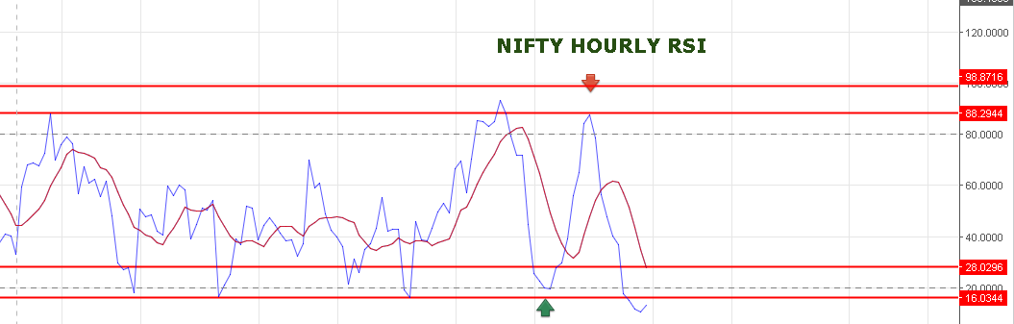
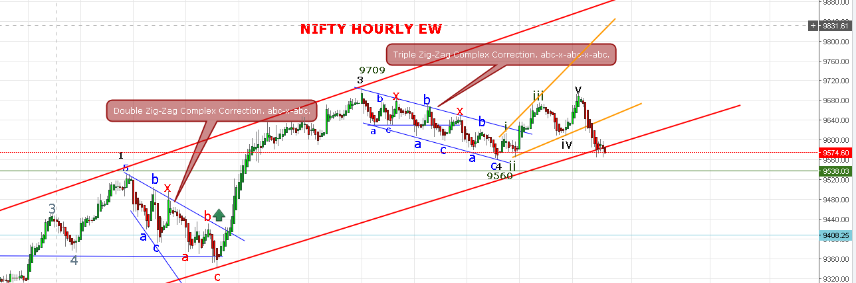

BULLISH VIEW AS PER EW:
9560 TO 9699=5(1).
9699 TO 9565=5(2)
9565 TO 98XX=5(3)
OR
7909=3.
7909 TO 9560=4A.
9560 TO 9699=4B.
9699 TO 9565=4C.

BEARISH VIEW AS PER EW:
9709 TO 9560=1
9560 TO 9699=2
9699 TO 94XX=3
WE ARE HOLDING LONG IN NF FROM 9620NF AND ADDED 9604 +9585NF. AVG COST @9603NF. NF CLOSED @9590. STOP 9568NF OR EQUIVALENT TO 9559 NS.
NIFTY SPOT WEAK BELOW 9602NS AND STRENGTH ABOVE 9629 ONLY.BULLISH ABOVE 9670NS.BEARISH BELOW 9550NS.
SINCE RSI ON HOURLY IS AT OVERSOLD ZONE SO PRICE CAN BOUNCE MINIMUM UP TO 9606-9615NS LEVEL. HOLDING ABOVE 9615 ON HOURLY BASIS WE CAN SEE FAST RISE UP TO 9641>9670 LEVEL.
NIFTY PIVOT @9596 SO SUSTAIN ABOVE IS BULLISH AND SUSTAIN BELOW 9590 IS BEARISH SIGNAL.
OPTION:
BUY & HOLD 9800JUNE PE AS LONG PRICE TRADING BELOW 9596.
BUY 9800JULY CE IF TRADE ABOVE 9606NS.

