NIFTY PREDICTION FOR 22/06/2017:
NIFTY TAKEN SUPPORT NEAR 9610 AND BOUNCE CLOSED ABOVE SAR.
SAR: 9620NS.

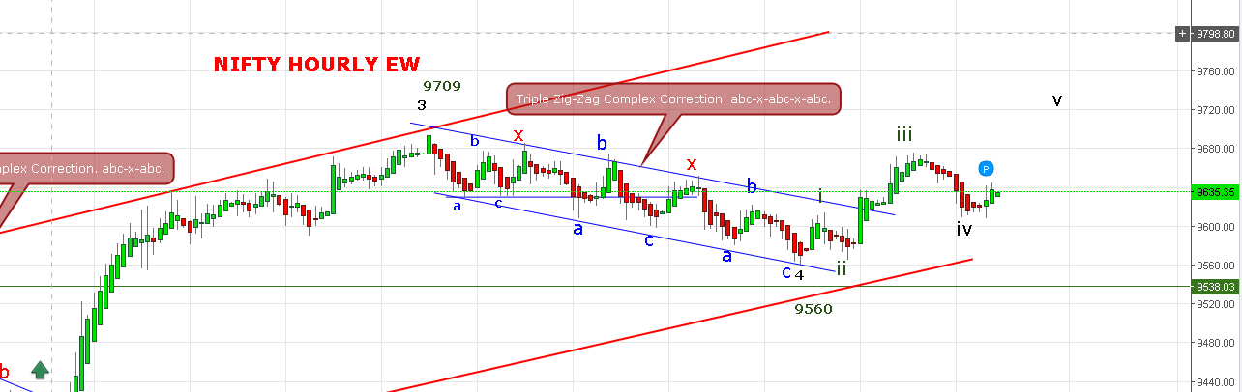

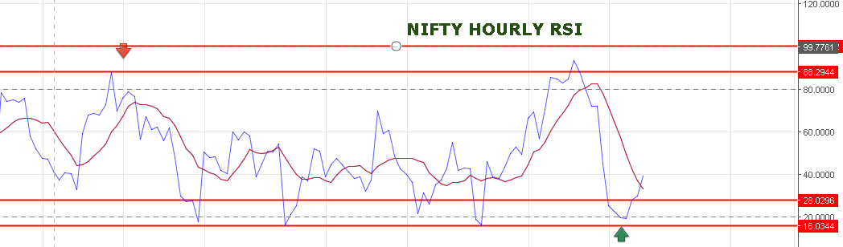
HOLDING LONG BOOK PART PROFIT NEAR 9710-9750 LEVEL.STOP 9603NS.REENTER IF TRADE ABOVE 9625 AFTER HITTING STOP.
SHORT ONLY @9600 NS STOP 9630NS.TARGET 9565-9520NS.
OPTION:
HOLD 9600CE STOP 70 BY CLOSING.
BUY 9800PE TRADE BELOW 9600NS.

