NIFTY PREDICTION FOR 20/06/2017:
PRICE NEGATE EVENING STAR, BOUNCE FROM CHANNEL END OF 4 WAVE.
SAR: 9619NS.
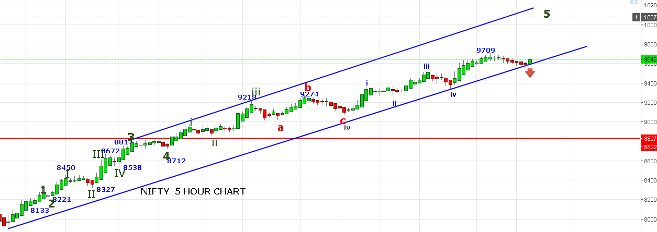
NOW ALL POSITIONAL LONG STOP 9619NS.
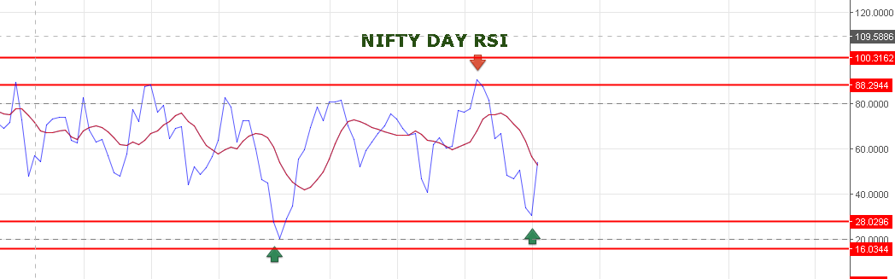
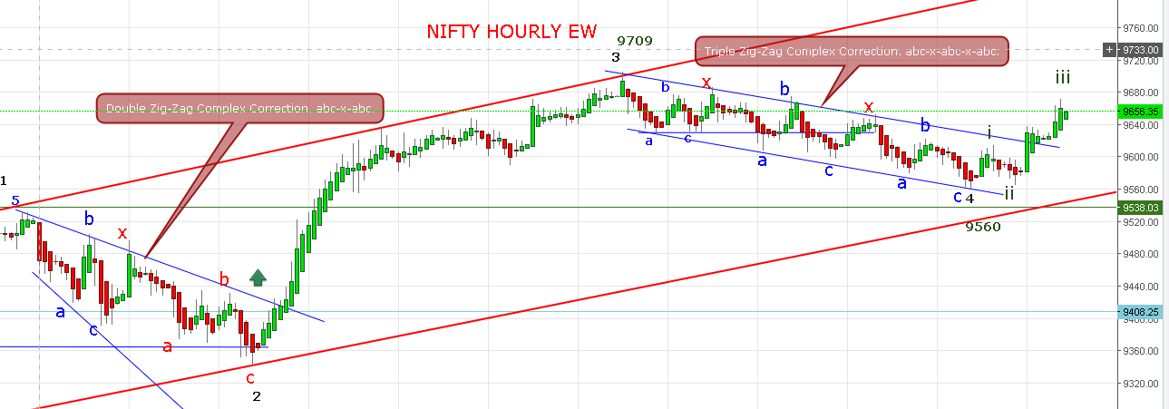

WAVE 4 ENDED AFTER TRIPLE COMPLEX CORRECTION @9560 AND WAVE 5(1)(i)(ii) DONE &(iii) IN PROGRESS.
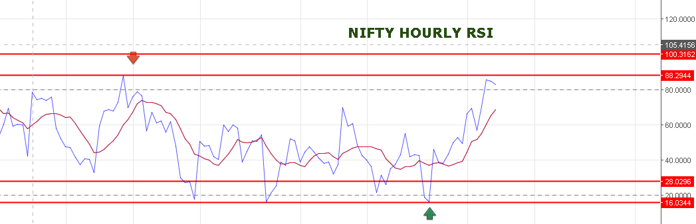
A GAP OF OPENING EXPECTED TOMORROW NEAR 9704-9710. RESISTANCE 9730-9750.
WE EXPECTING 9951-10037 MINIMUM TARGET.
OPTION:
9800PE STOP OUT AT OPENING @175.
BOUGHT 9600 @77 HOLDING STOP @70.

